 | 8:50 – 9:15 | 9:15 – 10:15 |  | 10:30 – 11.00 | 11:00 – 12:00 |  | 1:15 – 2:15 |  | 2:30 – 3:15 |  | 3:20 – 3:30
MONDAY |  | English –   | B |  | 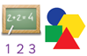  Maths | L |  | B |  |  | 
TUESDAY |   Class | Outdoor PE   | R |  | Maths | U | English | R |     Computing /PSHE
WEDNESDAY | Y1  RG/CK | English | E |  | Maths | N | Indoor PE   | E |   RE -Assessment
THURSDAY |  | English | A |  | Maths | C | Golden time | A | 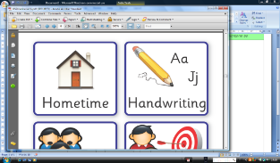  Handwriting - z | Sing and Praise
FRIDAY |  | Maths | K |  | Comprehension/Guided reading | H |  | K |   Music |  | 

