Minutes of KS staff meeting at St. John’s CE Primary School and Nursery

A copy of these minutes and all other minutes can be found on the school server, in the paperwork, meetings folder.

Staff present unless highlighted
Gartside Katherine | Hallam Rob | Cooper Claire | Higgs Hannah | Robinson Denise | Newton Sharon | Bennett Lucy
Thompson Charlotte | Carvell Mieke | Taylor Elizabeth | Winson-Bushby Jennifer
Smith Gemma | Garbutt Rebecca | Nicklin Cairen | Gallen Natalie | Wojcik Emma | Astell Kathryn | Badnam Raj
Christie Liz | Girling Deborah | Walker Ria | Lemon Nicola | Heer Karen

Date – Wednesday 3rd March, 2021
 | Agenda item | Action
Return on 8th March | - LA Risk Assessment has not been updated and remains at version 8.1 – vocabulary/emphasis change should/encouraged  - Celebration worship on Fridays will begin again on 12.03.21  - Lunchtime update – return to September provision with separate dinners and sandwiches due to numbers  - Staff unable to use the area for dinner  - Catch-Up groups 1:15 onwards in other areas – 1:30 the area will be open to use  - Learning at home – reward children for work at home when they return (credits)  - Home learning Books – encourage return to keep in school for future reference  - Beginning and end of day – no change to timetable
Emotional well-being | Support and free training links available on this site  https://derbyandderbyshireemotionalhealthandwellbeing.uk/
Safeguarding portfolio | MC reminded staff of where to go for safeguarding guidance and support documents  A hard copy of the portfolio is kept in RC’s office and a copy of the documents/links are on the server. There is also the safeguarding area in the staffroom for key guidance.  P:\Child Protection & Safeguarding\Guidance Document Portfolio\Guidance Documents Portfolio 2020-2021
Google Classroom Non-negotiables Checklist Audit | Results of the staff checklist can be found using the following link:  P:\Remote Learning\Staff Updates\Staff Checklist Results 03.02.21.pdf
Review of Remote Provision (DfE) | MC & SLT reviewed the remote education provision on 19.01.21 & MC reviewed this again on 27.02.21. The updates can be found using the link below:  P:\Remote Learning\Shared Documents\St John's Remote Education Provision Review V2.pdf
Remote Provision Evidence | MC requested a copy of engagement records/assessment for the period 5th January to 5th March for her Remote Education portfolio | - Provide MC with a copy of the documents by Friday 12th March
Internet Safety Audit | MC has drafted a questionnaire using Google Forms to get a picture of what apps are being used and how safely at home. Concerns have been expressed by some staff in recent days about the amount of time children appear to be on devices, the appropriateness of Apps and games being used and the children potentially watching films that are not age appropriate. | - Please ensure all children have completed this by Friday 19th March  - MC to use this information to inform a letter and guidance for parents before Easter.
Pupil Progress meetings | Updated timetable  P:\Pupil Progress\2020 - 2021 Timetable v3.docx | - Please give your Pupil Progress Data to MC by 5p.m. the day before your meeting is due
Wish List success | MC updated staff on the success of the wish list
Parents’ Evening | Email sent to you by RA on Monday with list of appointment requests  JP will distribute copies of the letter for children who haven’t booked an appointment  MC demonstrated how to set up separate meetings for parents’ evening  - Google Meet Parents’ evening Appointment request  - Go to Google Meet through the waffle  - Select  and   - Save the link created for a parent  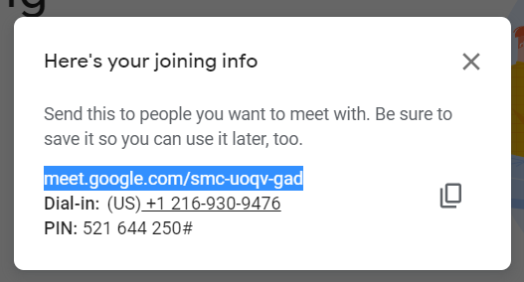  - Repeat this process for each parent to generate and save individual links  - Post on the stream individually when ready  Example:  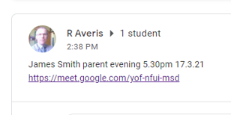  - Use this link to engage in the meeting  - Phone call request – email the appointment day/time | - Staff to see MC should they need any support or clarification of the instructions
English Update:  Writing focus | KA delivered a session reflecting her recent English briefing – Writing Cohesion  Staff were then asked to complete a task to assess/moderate cohesion in writing  EYFS were given the task of finding three ways they could improve the provision in respect of English – develop a more vocabulary rich environment, improve writing opportunities etc. | - Staff to use this information to moderate the cohesion in writing examples  - KA to distribute outcomes for writing  - EYFS to provide feedback to MC and implement the improvements decided on

