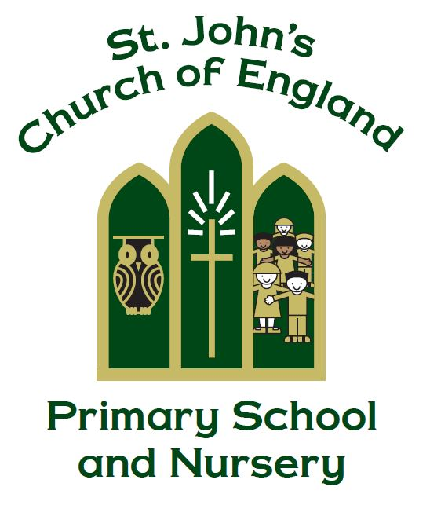

St. John’s C of E (VC) Primary School and Nursery

Modern Foreign Language [MFL] Policy

‘There are doubtless many different languages in the world, and none is without meaning’
Corinthians 14:10

Manager – Miss C. Thompson

Policy produced following consultation with the following parties

Staff on: 04.10.21

Full governors on

Policy review date: October 2023

Introduction

Learning a foreign language is part of the primary National Curriculum and is a requirement for all Key Stage Two (KS2) children. At St. John’s CofE Primary School and Nursery, we have adopted a whole school approach to the teaching and learning of Spanish.

Aims

Our aim is for children to develop confidence and competence when learning Spanish. We want children at St. John’s to be passionate, curious and confident about their own foreign language learning abilities.

We will help them develop and demonstrate substantial progress in the four key language skills necessary for learning Spanish:

- Speaking
- Listening
- Reading
- Writing

We aim to ensure that pupils of all abilities develop solid foundations in these key language learning skills. These skills will develop children’s ability to understand what they hear and read and enable them to express themselves in speech and writing. We will also help strengthen their sense of identity through learning about culture in other countries and comparing it with their own.

Languages in the National Curriculum

Our whole school approach to language teaching and learning is in line with the recommendations of the National Curriculum and the requirements outlined in the Department for Education Languages Programme of Study for KS2.

By the end of KS2, pupils should be able to:

- listen attentively to spoken language and show understanding by joining in and responding.
- explore the patterns and sounds of language through songs and rhymes and link the spelling, sound and meaning of words.
- engage in conversations; ask and answer questions; express opinions and respond to those of others; seek clarification and help.
- speak in sentences, using familiar vocabulary, phrases and basic language structures.
- develop accurate pronunciation and intonation so that others understand when they are reading aloud or using familiar words and phrases.
- present ideas and information orally to a range of audiences.
- read carefully and show understanding of words, phrases and simple writing.
- appreciate stories, songs, poems and rhymes in the language.
- broaden their vocabulary and develop their ability to understand new words that are introduced into familiar written material, including through using a dictionary.
- write phrases from memory, and adapt these to create new sentences, to express ideas clearly.
- describe people, places, things and actions orally and in writing.
- understand basic grammar appropriate to the language being studied, including (where relevant): feminine, masculine and neuter forms and the conjugation of high-frequency verbs; key features and
- patterns of the language; how to apply these, for instance, to build sentences; and how these differ from or are similar to English.

Teaching and Learning

Language Angels is the provider of the scheme of work for our Spanish teaching and learning at St. John’s. Teachers plan and resource their lessons using Language Angels and are encouraged to supplement this with their own ideas and experience and those of their colleagues.

The lessons are designed to motivate, captivate and interest children from the first moment. They have clear, achievable objectives and incorporate different learning styles. Children with SEN have access to the curriculum through variation of task, grouping or support from an adult.

Language Angels has many exciting and interesting units to choose from. The units are categorised into Early Language (aimed at Year Three), Intermediate (aimed at Years Four and Five) and Progressive (aimed at Year Six).

Spanish at St. John’s is taught in a whole-class setting. Each class teacher will timetable at least thirty minutes per week for the teaching of Spanish. Spanish should be revisited in short sessions throughout the week to consolidate knowledge and ensure new language is retained and embedded. As this is a new language from September 2021, we ask that class teachers teach Spanish and do not leave it for PPA cover.

All year groups will be teaching the same units, from Early Language, September 2021 – July 2022. This is because Spanish is a new language this academic year and therefore all children need to start with the early language units. We are learning Spanish together as a school.

The MFL lead will produce an annual overview for teachers, which can be found on the school sever or the school website. The MFL lead will share any updates and changes to the teaching overviews in a timely manner.

Languages in the Early Years Foundation Stage(EYFS) and Key Stage One (KS1)

Although teaching a language in EYFS and KS1 is not statutory, at St John’s we aim to instill the love of learning a language early on. There is no set timetable for EYFS or KS1 – teachers can implement Spanish collaboratively in the classroom, as they best see fit e.g. songs and basic vocabulary. Language Angels can be utilised for the interactive games and the KS1 appropriate units, like ‘Nursery Rhymes’ and ‘Seasons KS1’.

Evidence of Teaching & Learning

When starting Year Three, children will receive a Spanish folder. Where appropriate, worksheets completed by the children can be kept in their individual folders. These folders can stay with the children and must be passed up throughout KS2 and become a portfolio of their learning. The unit learning intention sheet, from Language Angels, should be at the front with their work for the unit behind, stapled together.

Key phrases to use in the classroom:



