If you are bullied:-
DO…
- Ask them to STOP if you can.
- Use eye contact and tell them to
go away.
- Ignore them.
- Walk away
- Talk to any grown up.
- Talk to a Playground Pal.
- Tell your friends.
- TELL ANYONE THAT YOU TRUST!
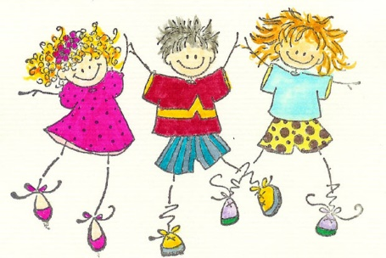
DON’T…
- Don’t do what they say.
- Don’t get angry or look upset.
- Don’t hit them.
- Don’t think it is your fault.
What should I do if I see someone else being bullied?

DO…
- Tell a trusted adult what you have seen.
- Tell the bully to stop if it is safe to do so.
DON’T…
- Don’t walk away and ignore the bullying.
- Don’t stay silent or the bullying will keep happening.

Mr. Averis, all the staff all the children and Governors of St. John’s will work together to:-
- Make our school a place where everyone can feel safe. That means no bullying allowed!
- We will help everyone to get on with each other.

St John’s CE Primary School
and Nursery


Our Anti-Bullying
Policy

Written by Mrs Girling with the help of the children from St John’s CE Primary School.

What is bullying?
In our school, a bully is someone who hurts someone more than once by using behaviour which is meant to hurt, frighten or upset another person.
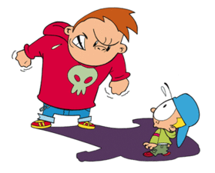
Bullying can be…
Emotional: Hurting people’s feelings, leaving you out.
Physical: Punching, kicking, spitting, pushing, pinching, hitting.
Verbal: Being teased, name calling.
Racist: Calling you racist names.
Cyber: Saying unkind things by text, e-mail and social networking.
When is it bullying?

Several
Times
On
Purpose
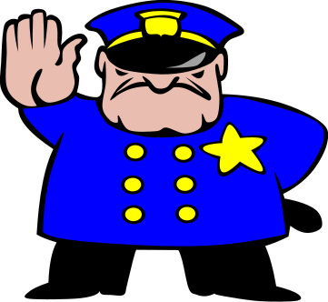

Who can I tell?

A friend
Mum/Dad
Teachers
Playground Pal
School friends
Dinner lady
Any other adult

AND MOST IMPORTANTLY…
if you are being bullied
START Telling Other People

