

St. John’s CE Primary School and Nursery

‘So teach us to number our days, that we may get a heart of wisdom.’

Psalm 90:12

Calculation Policy

Manager Mrs S Newton

Policy Produced following consultation with the following parties

Staff throughout Spring term – May 2026

Curriculum Governors on: 21st MAY 2026

Policy review Date July 2028

This policy is to be used in conjunction with all other policies at St. John’s C. of E. Primary School and Nursery

Addition
Objective and Strategies | Concrete |  | Pictorial | Abstract
Combining two parts to make a whole: part- whole model | 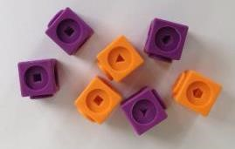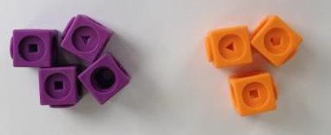 |  | 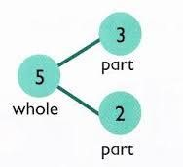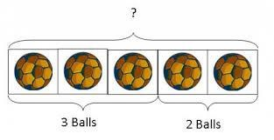  Use  pictures to  add two numbers  together as a  group or in a bar. |   Use the  part  -  part  whole diagram as  shown above to  move into the  abstract.  5 + 3 = 8  8 = 3 + 5 |   5  3
    8 |   1
Combining two parts to make a whole: part- whole model | 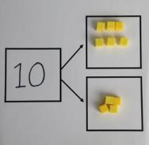  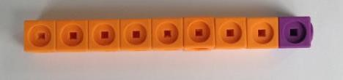 | Use cubes to add two numbers together as a group or in a bar.
Starting at the bigger number and counting  on | 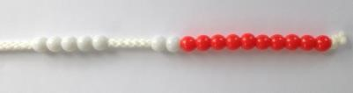  Start with the larger number on the bead string and then count on to the smaller number 1 by 1 to find the answer. |  | 12 + 5 = 17  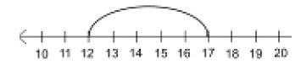  Start at the larger number on the number line and count on in ones or in one jump to find the answer. | 5 + 12 = 17  Place the larger number in your head and count on the smaller number to find your answer.

Regrouping to make 10. | 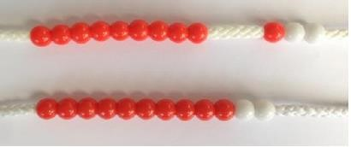  6 + 5 = 11  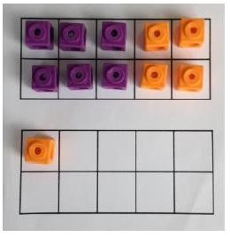  Start with the bigger number and use the smaller number to make 10. | 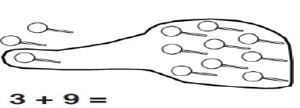  Use pictures or a number line. Regroup or partition the smaller number to make 10.  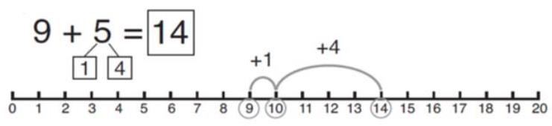 | 7 + 4= 11  If I am at seven, how many more do I need to make 10. How many more do I add on now?
Adding three single digits | 4 + 7 + 6= 17  Put 4 and 6 together to make 10. Add on 7.  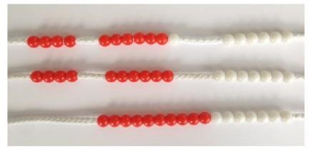  Following on from making 10, make 10 with 2 of the digits (if possible) then add on the third digit. | 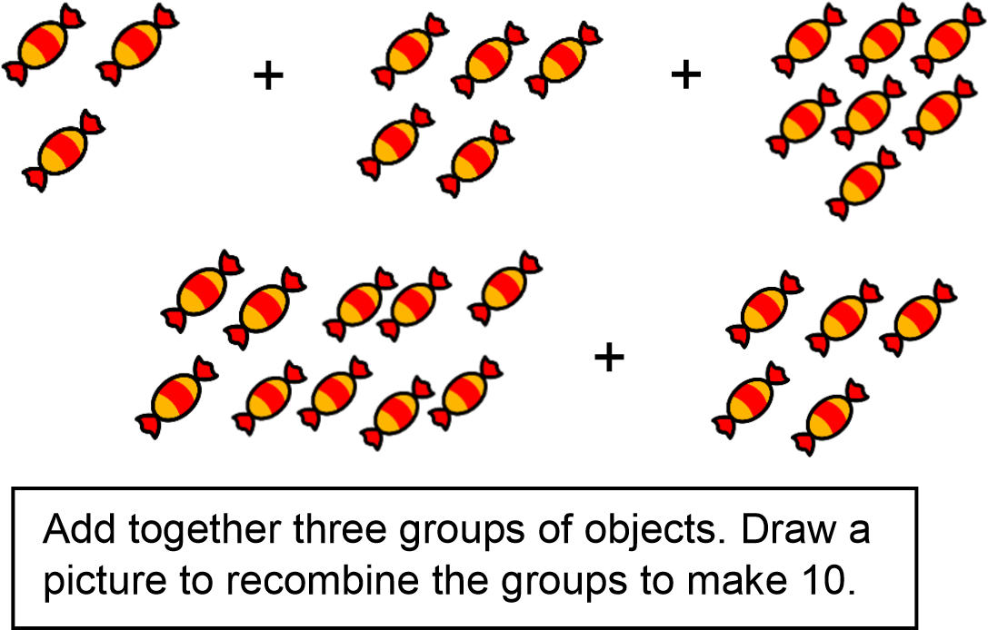 | 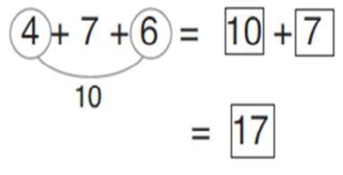  Combine the two numbers that make 10 and then add on the remainder.
T.O.T.  (tens, ones, total) | Children use Dienes apparatus to build, then partition two digit numbers into tens and ones, ready for adding.  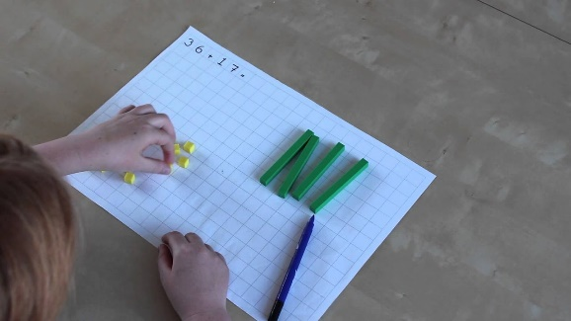 | 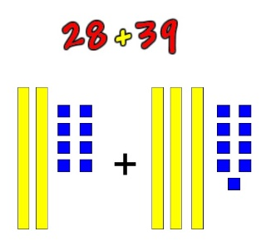  Children then draw the Dienes to represent calculations (Y2 objective: use different representations to solve addition problems).  Variation can come through use of P.V. counters for further representations. | 28 + 39 =  20 + 30 = 50 (Add the TENS)  8 + 9 = 17 (Add the ONES)  50 + 17 = 67 (TOTAL altogether)
Column method- no regrouping | 24 + 15=  Add together the ones first then add the tens. Use the Base 10 blocks first before moving onto place value counters.  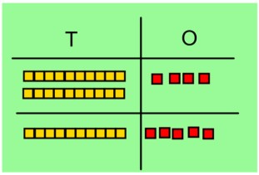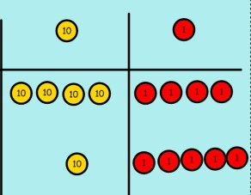 | After practically using the base 10 blocks and place value counters, children can draw the counters to help them to solve additions. | 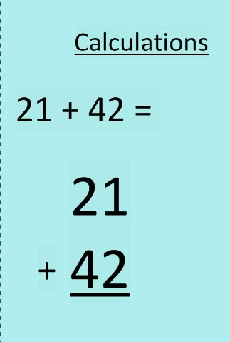
  T | O
Column method- regrouping | Make both numbers on a place value grid.  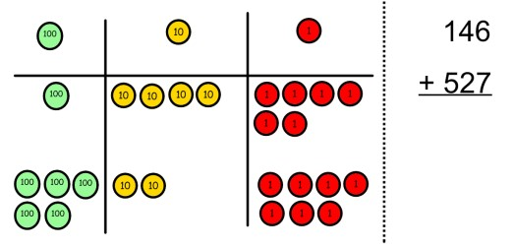  Add up the units and exchange 10 ones for one 10.  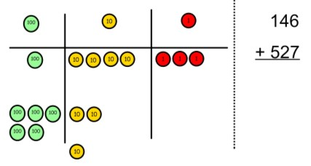  Add up the rest of the columns, exchanging the 10 counters from one column for the next place value column until every column has been added.  This can also be done with Base 10 to help children clearly see that 10 ones equal 1 ten and 10 tens equal 100.  As children move on to decimals, money and decimal place value counters can be used to support learning. | Children can draw a pictoral representation of the columns and place value counters to further support their learning and understanding.  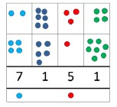 | Start by partitioning the numbers before moving on  to clearly show the exchange below the addition.  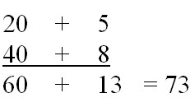  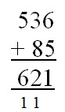  As the children move on, introduce decimals with the same number of decimal places and different. Money can be used here.  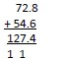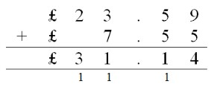  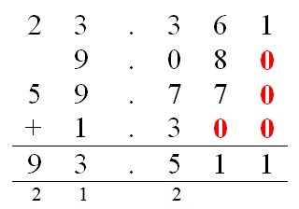

Subtraction
Objective and Strategies | Concrete | Pictorial | Abstract
Taking away ones | Use physical objects, counters, cubes etc to show how objects can be taken away.      6 – 2 = 4 | Cross out drawn objects to show what has been taken away.  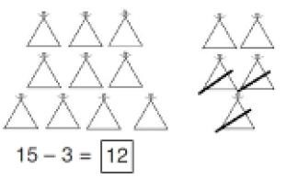 | 18 -3= 15  8 – 2 = 6
Counting back | 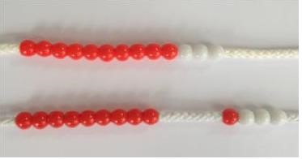  Make the larger number in your subtraction. Move the beads along your bead string as you count backwards in ones.  13 – 4  Use counters and move them away from the group as you take them away counting backwards as you go.  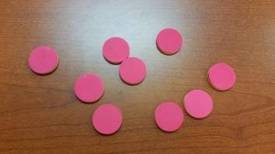 | Count back on a number line or number track  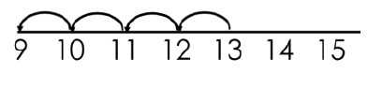  Start at the bigger number and count back the smaller number showing the jumps on the number line.  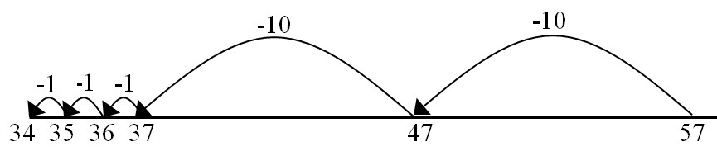  This can progress all the way to counting back using two 2 digit numbers. | Put 13 in your head, count back 4. What number are you at? Use your fingers to help.

Find the difference | Compare amounts and objects to find the difference.  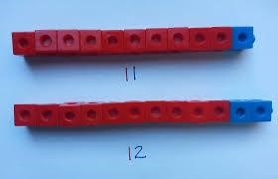  Use cubes to build towers or make bars to find the difference  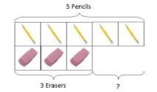  Use basic bar models with items to find  the difference | 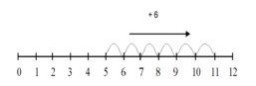  Count on to find the difference.  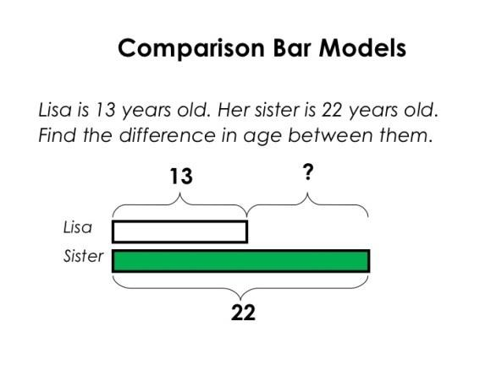  Draw bars to  find the difference between 2 numbers. | Hannah has 23 sandwiches, Helen has 15 sandwiches. Find the difference between the number of sandwiches.
Part Part  Whole Model | 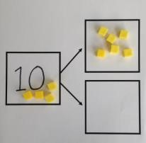  Link to addition- use the part whole model to help explain the inverse between addition and subtraction.  If 10 is the whole and 6 is one of the parts. What is the other part?  10 - 6 = | Use a pictorial representation of objects to show the part part whole model.   |   10  5  Move to using numbers within the part whole model.
Make 10 | 14 – 9 =  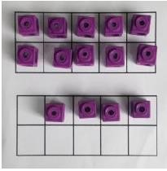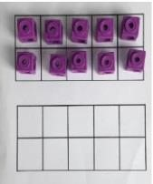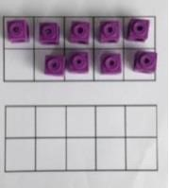  Make 14 on the ten frame. Take away the four first to make 10 and then takeaway one more so you have taken away 5. You are left with the answer of 9. | 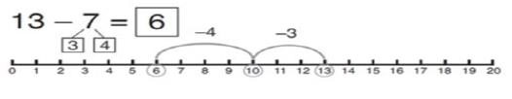  Start at 13. Take away 3 to reach 10. Then take away the remaining 4 so you have taken away 7 altogether. You have reached your answer. | 16 – 8=  How many do we take off to reach the next 10?  How many do we have left to take off?

Two-digit subtraction. | Concrete use of Dienes to build, partition and the subtract tens, then ones. | 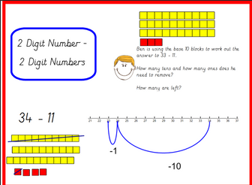 | 34 – 11 =  (partition 11 into 10 and 1)  34 – 10 = 24  24 – 1 = 23
Column method without regrouping | 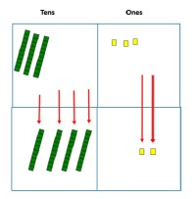  Use Base 10 to make the bigger number then take the smaller number away.  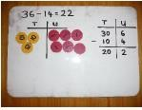  Show how  you partition numbers to subtract.  Again make the larger number first.  NB: USE ONES (O), NOT UNITS (U) | 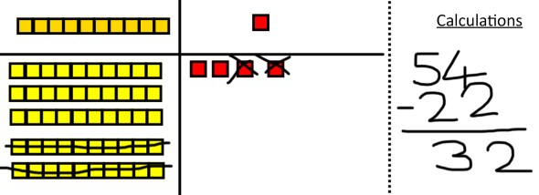  Draw the Base 10 or place value counters alongside the written calculation to help to show working.  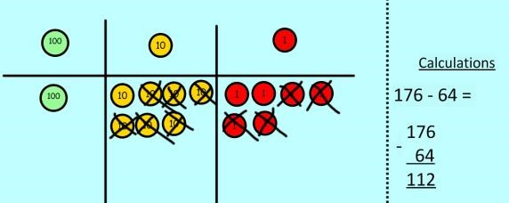 | 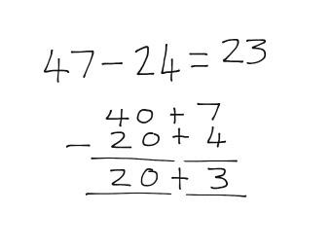  This will lead to a clear written column subtraction.  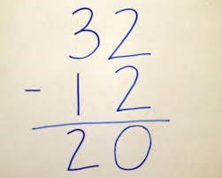
Column method with regrouping | Use Base 10 to start with before moving on to place value counters. Start with one exchange before moving onto subtractions with 2 exchanges.  Make the larger number with the place value counters  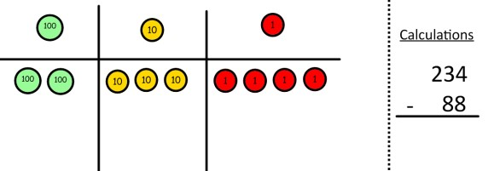  Start with the ones, can I take away 8 from 4 easily? I need to exchange one of my tens for ten ones.  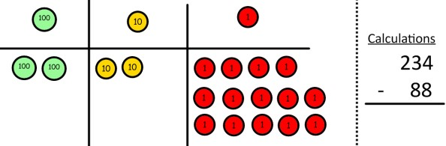 | 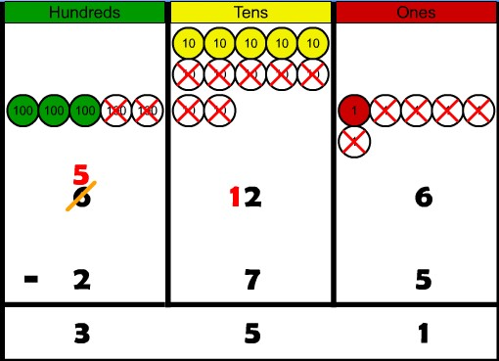  Draw the counters onto a place value grid and show what you have taken away by crossing the counters out as well as clearly showing the exchanges you make.  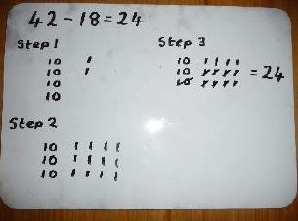  When confident, children can find their own way to record the exchange/regrouping.  Just writing the numbers as shown here shows that the child understands the method  and knows when to exchange/regroup. | 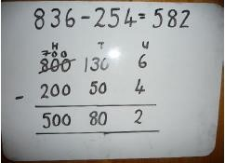  Children can start their formal written method by partitioning the number into clear place value columns.  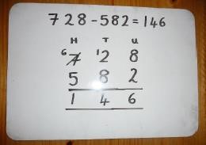  Moving forward the children use a more compact method.
 | Now I can subtract my ones.  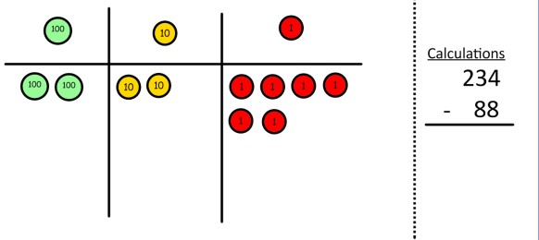  Now look at the tens, can I take away 8 tens easily? I need to exchange one hundred for ten tens.  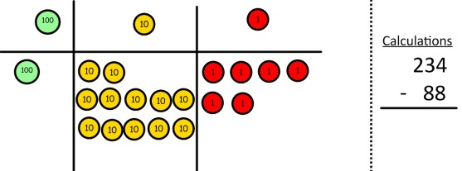  Now I can take away eight tens and complete my subtraction  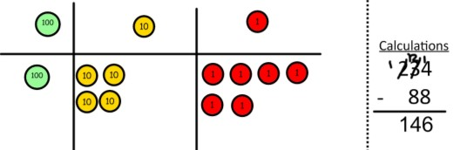  Show children how the concrete method links to the written method alongside your working. Cross out the numbers when exchanging and show where we write our new amount. |  | This will lead to an understanding of subtracting any number including decimals.  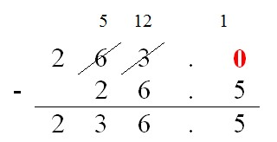

Multiplication
Objective and Strategies | Concrete | Pictorial | Abstract
Doubling | Use practical activities to show how to 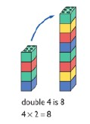 double a number. | Draw pictures to show how to double a number.  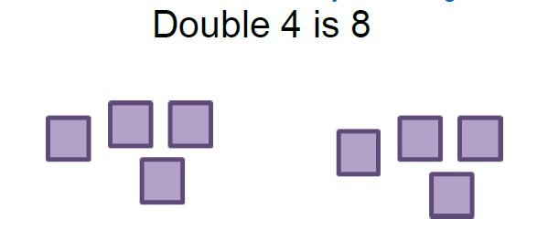 | 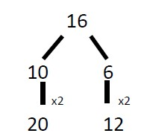  Partition a number and then double each part before recombining it back together.
Counting in multiples | 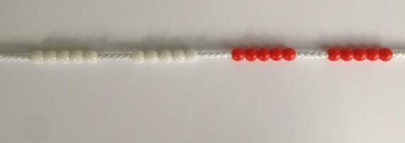  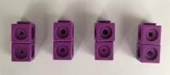  Count in multiples supported by concrete objects in equal groups. | 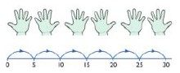  Use a number line or pictures to continue support in counting in multiples. | Count in multiples of a number aloud.  Write sequences with multiples of numbers.  2, 4, 6, 8, 10  5, 10, 15, 20, 25 , 30

Repeated  addition | 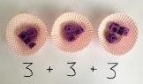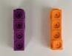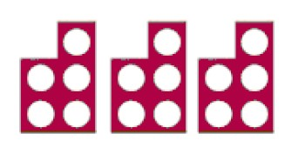  Use different  objects to add  equal groups. | 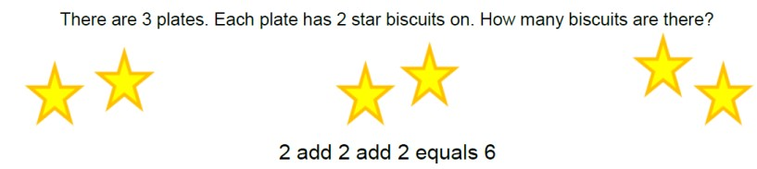  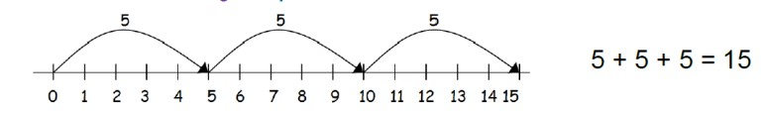 | Write addition sentences to describe objects and pictures.  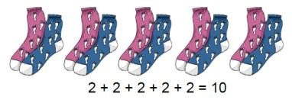
Arrays- showing  commutative multiplication | Create arrays using counters/ cubes to show multiplication sentences.  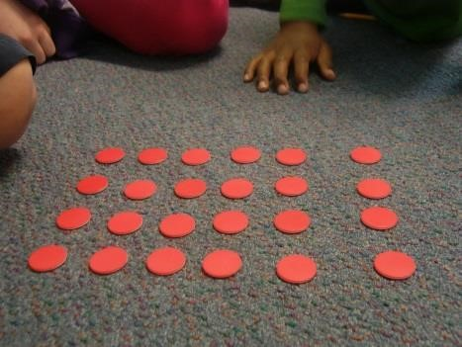  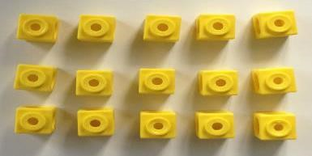 | 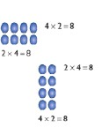  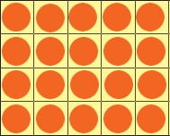  Draw arrays in different rotations  to find commutative multiplication sentences.  Link arrays to area of rectangles. | Use an array to write multiplication sentences and reinforce repeated addition.  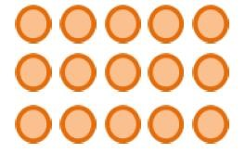  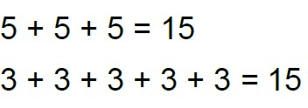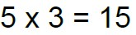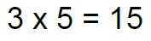

Column  multiplication | Children can continue to be supported by place value counters at the stage of multiplication.  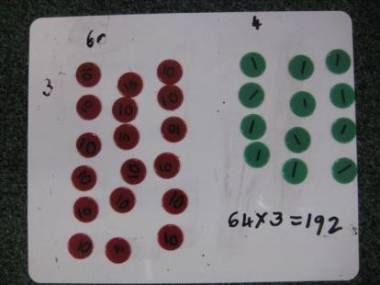  It is important at this stage that they always multiply the ones first and note down their answer followed by the tens which they note below. | Bar modelling and number lines can support learners when solving problems with multiplication alongside the formal written methods.  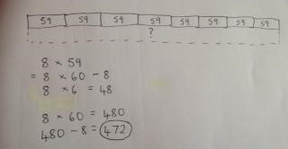  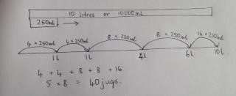 | Start with long  multiplication, reminding the children about lining up their numbers clearly in columns.  If it helps, children can write out what they are solving next to their answer.  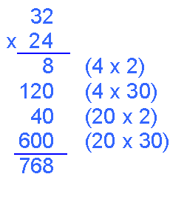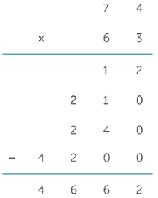  This moves to the more compact method.  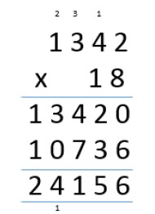
Division
Objective and Strategies | Concrete | Pictorial | Abstract
Sharing objects into groups | 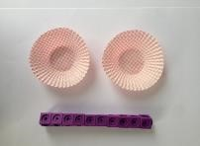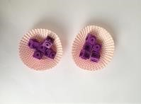  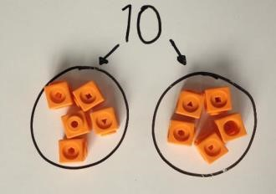  I have 10 cubes, can you share them equally in 2 groups? | Children use pictures or shapes to share quantities.    8  ÷  2  =  4 | Share 9 buns between three people.  9 ÷ 3 = 3
Division as grouping | Divide quantities into equal groups. Use cubes, counters, objects or place value counters to aid understanding.  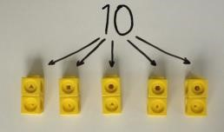  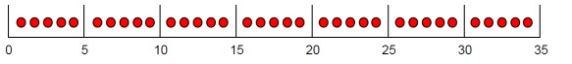  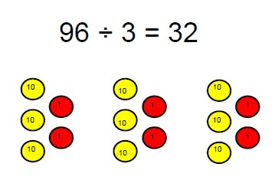 | Use a number line to show jumps in groups. The number of jumps equals the number of groups.  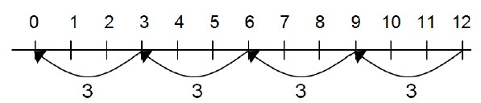  Think of the bar as a whole. Split it into the number of groups you are dividing by and work out how many would be within each group.  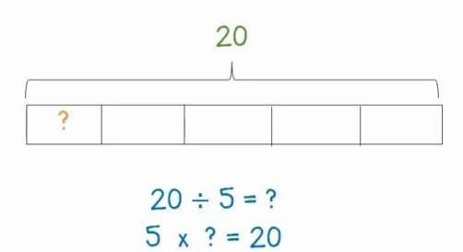 | 28 ÷ 7 = 4  Divide 28 into 7 groups. How many are in each group?

Division within arrays | 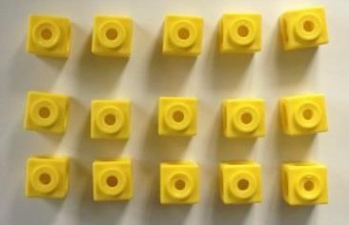  Link division  to multiplication by creating an array and thinking about the  number sentences that can be created.  Eg 15 ÷ 3 = 5 5 x 3 = 15  15 ÷ 5 = 3 3 x 5 = 15 | 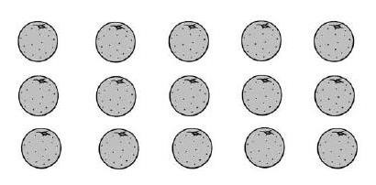Draw an array and use lines to split the array into groups to make multiplication and division sentences. | Find the inverse of multiplication and division sentences by creating four linking number sentences.  7 x 4 = 28  4 x 7 = 28  28 ÷ 7 = 4  28 ÷ 4 = 7
Division with a remainder | 14 ÷ 3 =  Divide objects between groups and see how much is left over  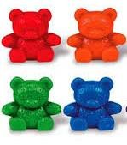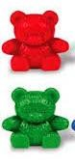 | Jump forward in equal jumps on a number line then see how many more you need to jump to find a remainder.  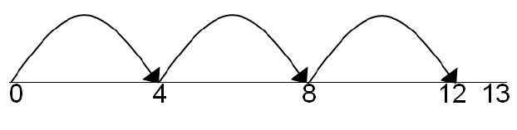  Draw dots and group them to divide an amount and clearly show a remainder.  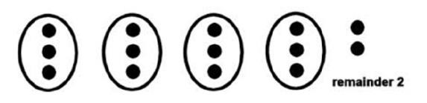 | Complete written divisions and show the remainder using r.  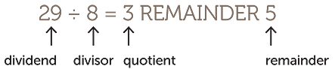

Short division | 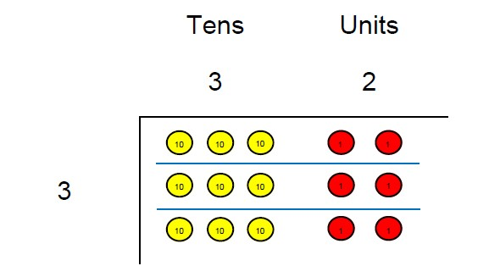  Use place value counters to divide using the bus stop method alongside  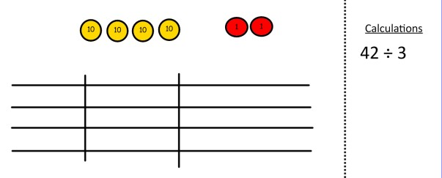  42 ÷ 3=  Start with the biggest place value, we are sharing 40 into three groups. We can put 1 ten in each group and we have 1 ten left over.  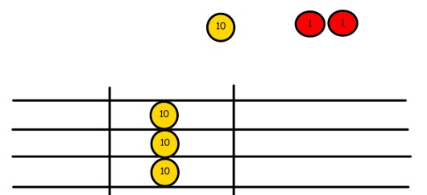  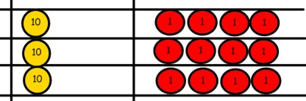  We exchange this ten for ten ones and then share the ones equally among the groups.  We look how much in 1 group so the answer is 14. | Students can continue to use drawn diagrams with dots or circles to help them divide numbers into equal groups.  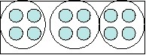  Encourage them to move towards counting in multiples to divide more efficiently. | Begin with divisions that divide equally with no remainder.  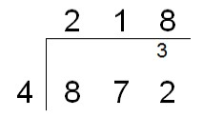  Move onto divisions with a remainder.  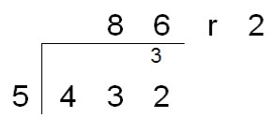  Finally move into decimal places to divide the total accurately.  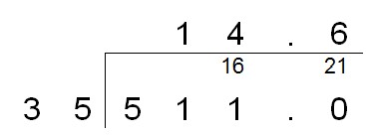  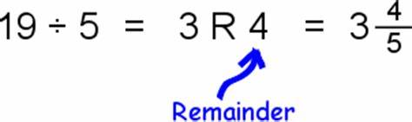
Long division | 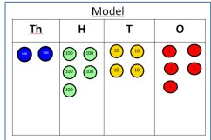  2544 ÷ 12  How many groups of 12 thousands do we have?  None  Exchange 2 thousand for 20 hundreds.  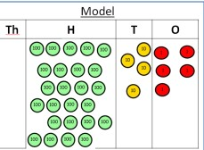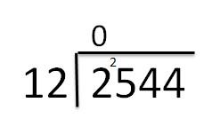  How many groups of 12 are in 25 hundreds? 2 groups. Circle them.  We have grouped 24 hundreds so can take them off and we are left with one.  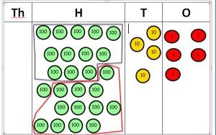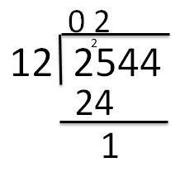  Exchange the one hundred for ten tens so now we have 14 tens. How many groups of  12 are in 14? 1 remainder 2  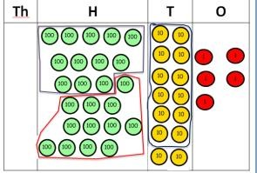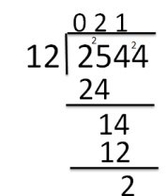  Exchange the two tens for twenty ones so now we have 24 ones. How many groups of  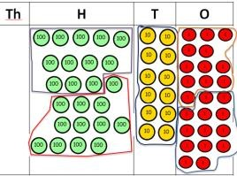  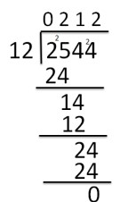  12 are in 24? 2 | Instead of using physical counters, students can draw the counters and circle the groups on a whiteboard or in their books.  Use this method to explain what is happening and as soon as they have understood what move on to the abstract method as this can be a time consuming process. | 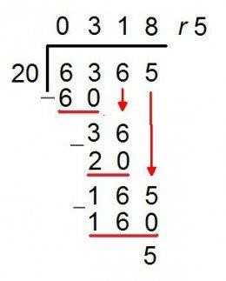  NB: Remainders as fractions:  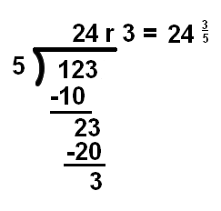

Glossary of key terms.
Term | Definition
Abstract representation | Using numbers or letters to record mathematical representations.  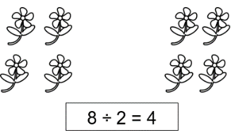  Abstract form
Addition as aggregation | I have some pencils on the desk.  4 are red, 3 are green. How many do I have altogether?  All pencils are already on the desk – no new ones are added.
Addition as augmentation | There are 7 children in the swimming pool.  Two more children jump in. How many are in the swimming pool now?  New children arrive and add to those who are already there.
Array | An arrangement of objects or shapes into equal rows and columns.  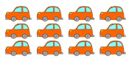
Commutative Law | 3 + 5 = 8 so 5 + 3 = 8  Digit order is expressions (without an =) or equations (with an =) is unimportant when adding or multiplying.  8 = 5 + 3 so 8 = 3 + 5.
Concrete representation | Use of concrete resources (Dienes, counters, place value cards…) to expose and represent mathematical structure.
Distributive Law | 24 x 3 = 72  20 x 3 = 60  4 x 3 = 12  60 + 12 = 72
Division as grouping | 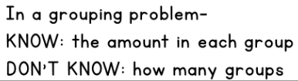  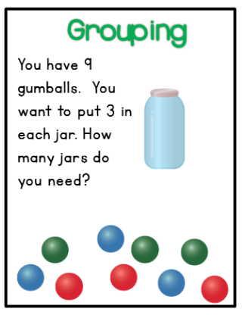
Division as sharing | 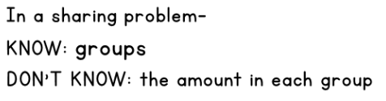  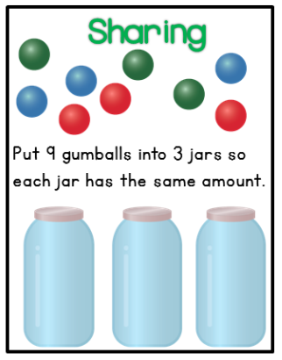
Inverse | 3 + 4 = 7, so 7 – 3 = 4.  3 x 4 = 12, so 12 ÷ 3 = 4.
Pictorial representation | Use of pictures to expose and represent mathematical structure.
Multiple | A number which can be divided by another number without a remainder.  For example: 32 ÷ 4 = 8, so 32 is a multiple of 4 (in the 4 x table) and 8 (in the 8 x table).
Renaming | 200 = 20 tens = 200 ones. It can also equal 1 hundred and 5 twenties, or 1 hundred and 10 tens.  35 = 3 tens and one 5 = seven 5s = 35 ones. It can also equal 20 and 15 ones, 30 and 5 ones.
Regrouping | Ten 1s = 10  Ten 10s = 100  Ten 100s = 1000  Ten 1000s = 10000
Variation | Picking apart and representing problems in different way, using the most appropriate and purposeful representations.

