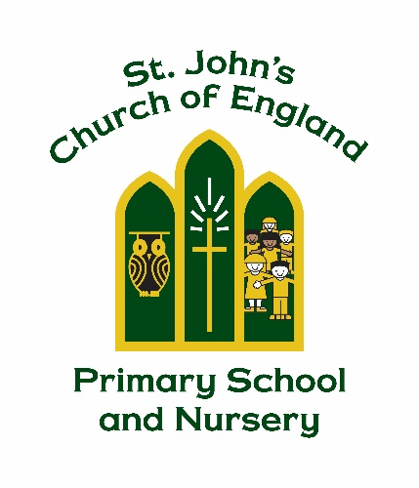

St. John’s Church of England Primary School and Nursery

Jesus said, “Let the little children come to me, and do not hinder them, for the kingdom of heaven belongs to such as these.”

Matthew 19 V 14

EYFS ClassDojo Policy

Manager: Mrs Jo Richardson

Policy Produced following consultation with the following parties

EYFS staff on

Full governors on 10.09.25, 24.09.26

Policy review Date : July 2028

Signed by the Chair of Governors

Date ______________________________

At St John’s CofE Primary and Nursery School, we believe that a strong partnership between home and school plays a vital role in every child’s education. We are committed to ensuring that all members of our school community—children, parents/carers, staff, governors, and visitors—are valued, respected, and supported equally.

This policy outlines our use of ClassDojo, an online platform that supports communication between school and home. ClassDojo helps us share learning, celebrate achievements, and keep families informed through features such as:
- A secure feed for photos, videos, and updates from the school day
- Messaging between staff and parents/carers, with translation available in over 35 languages
- Class and school-wide sharing of learning moments and celebrations
ClassDojo is used in line with our safeguarding, data protection, and communication policies to ensure a safe and positive experience for all users.

Introduction to ClassDojo
ClassDojo is an online tool that supports communication between school and home. It offers a range of useful features, including:
- Direct messaging between teachers and parents/carers
- Class and school newsfeeds for sharing updates, photos, and videos
- Value-based rewards and celebration of learning moments
- Instant translation of Class Story posts into over 35 languages

ClassDojo is free to use and works on iOS, Android, Kindle Fire devices, and web browsers.
To ensure ClassDojo is used safely and effectively, this policy outlines the expectations and responsibilities for both staff and parents/carers. It is designed to keep ClassDojo a positive and secure communication tool for our school community.

ClassDojo operates in accordance with UK GDPR and Data Protection legislation. St John's CofE Primary and Nursery School remains the Data Controller for pupil information shared through the platform. Information is only shared where appropriate and in line with our Data Protection, Safeguarding and Online Safety Policies. Parents/carers should refer to the school's Privacy Notice for further information regarding how personal data is processed.
All information shared on ClassDojo is private between teachers, parents/carers, and students. ClassDojo does not sell data and permanently deletes student information when accounts are no longer in use. Teachers, parents, and students can access and delete their information at any time.

How ClassDojo Works
ClassDojo is primarily used for sharing learning, celebrating achievements and providing updates. It should not be used to report absences, discuss confidential matters, or communicate urgent information. Parents/carers should continue to contact the school office directly for these matters.

Once parents/carers have signed the User Agreement, class teachers will provide a unique passcode to connect them to their child’s account.
ClassDojo is used in Nursery and Reception, and accounts are set up by the Early Years Lead.

Pupils will have access to their own ClassDojo area, here they can personalise their avatar and view their Dojo points.
We use ClassDojo to share updates about school events, send reminders, and celebrate learning and achievements.

ClassDojo has three main elements we use in school:

Digital Credit Points
Children earn Dojo points (credits) from staff for showing positive behaviours such as kindness, resilience, teamwork, and actions linked to our school values.

Class Story
This is where teachers post general class news, reminders, and updates for parents/carers to view.

WOW Moments
We celebrate children’s achievements and learning experiences both in school and at home.

Responsibility of Parents/Carers Using ClassDojo
ClassDojo is available only to parents/carers who hold legal parental responsibility for children registered at St John’s CofE Primary and Nursery School.

To ensure ClassDojo remains a safe and positive communication tool, parents/carers are expected to follow these guidelines:

✅ Do not share or repost content: Images, videos, or messages shared on ClassDojo must not be copied or posted elsewhere online (e.g. social media).
✅ Respect privacy: What is posted in ClassDojo stays in ClassDojo. Breaching this requirement may result in account suspension.
✅ Access is limited: Only parents/carers or legal guardians will be given access codes. Up to two parents may be linked to a child’s account. Additional adults may be added in exceptional circumstances, with approval from the Headteacher.
✅ View and engage: Parents/carers can view their child’s class story feed. They may comment on posts related to their child, but our preferred method of communication at St John’s remains face-to-face or by phone.
✅ Respect staff time: Teachers and staff may not post during teaching hours as they are focusing on teaching and learning.
✅ Protect confidentiality: Parents/carers must not share photographs, messages, or work samples from ClassDojo on personal social media accounts.
✅ Follow communication guidelines: Sharing private or confidential material may result in removal from ClassDojo.
✅ Understand posting frequency: The number of posts may vary week to week and between Nursery and Reception, depending on school activities and events.

Responsibility of Teachers and School Staff Using ClassDojo
To ensure ClassDojo is used effectively and safely, staff members are expected to follow these guidelines:

✅ Weekly updates: Teachers and support staff are encouraged to share updates on their class page regularly. The amount and type of posts are at their discretion and may include reminders e.g. Forest School, PE days, class events, trips, meetings, and celebrations of learning.
✅ Naming conventions: Only children’s first names will be used in posts. If more than one child shares the same first name, the first initial of their surname may be included.
✅ Sensitive information: Teachers must not share sensitive or private information on the Class Story. Such matters should be communicated directly with parents/carers.
✅ Photo permissions Staff must be fully aware of pupils whose parents/carers have not granted permission for images to be shared through school communication platforms and must ensure these preferences are respected at all times.
✅ Content sharing: Photos, videos, messages, and work samples should only be shared for pupils whose parents/carers have given explicit permission.
✅ Privacy protection: Staff must not share any ClassDojo content on personal social media accounts.
✅ App usage: Staff are not expected to monitor or respond to ClassDojo messages outside their normal working hours. Parents/carers should not use ClassDojo for urgent communications, absence reporting, safeguarding concerns, or matters requiring an immediate response.

Agreement and Compliance
By participating in ClassDojo, staff and parents/carers at St John’s CofE Primary and Nursery School agree to follow the terms outlined in this policy. These guidelines are in place to ensure ClassDojo remains a safe, respectful, and effective communication tool for our school community.

If any of these terms are breached, the Headteacher will determine an appropriate course of action, which may include suspension or removal from the platform.

Safeguarding
Any safeguarding concerns disclosed through ClassDojo will be dealt with in accordance with the school's Safeguarding and Child Protection Policy. Parents/carers should not use ClassDojo to report safeguarding concerns or emergencies. Such concerns should be reported directly to the school by telephone or in person.

