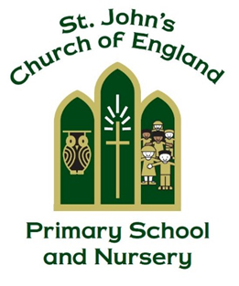

St. John’s CE Primary School and Nursery

English Policy

‘Your word is a lamp to my feet and a light to my path’
Psalm 119:105

Manager: Mrs K. Heer

Policy Produced following consultation with the following parties

Staff on 07.05.25

Curriculum Governors on 22.05.25

Policy Review Date May 2027

Signed by the Chair of Governors

Date ______________________________

This policy is to be used in conjunction with all other policies at St. John’s C. of E. Primary School and Nursery

Rationale.
This document is a statement of the aims, principles, strategies and procedures for the teaching and assessment of English at St. John’s Church of England Primary School and Nursery. This policy document describes the strategy agreed by the staff and governing body for the delivery of English.

At St. John’s Church of England Primary School and Nursery, we believe that English teaches us essential skills which enable us to communicate effectively through listening, speaking, reading and writing, encompassing a lifelong love of reading. It is vital that all children develop literacy skills to enable them to access our school curriculum and provide them with the capacity to fulfil their potential in life. We aim to fulfil the aims of the National Curriculum as outlined below:

National Curriculum 2013
The overarching aim for English in the National Curriculum is to promote high standards of language and literacy by equipping pupils with a strong command of the spoken and written word, and to develop their love of literature through widespread reading for enjoyment.

The National Curriculum for English aims to ensure that all pupils:
- read easily, fluently and with good understanding
- develop the habit of reading widely and often, for both pleasure and information
- acquire a wide vocabulary, an understanding of grammar and knowledge of linguistic conventions for reading, writing and spoken language
- appreciate our rich and varied literary heritage
- write clearly, accurately and coherently, adapting their language and style in and for a range of contexts, purposes and audiences
- use discussion in order to learn; they should be able to elaborate and explain clearly their understanding and ideas
- are competent in the arts of speaking and listening, making formal presentations, demonstrating to others and participating in debate.

Reading
From the earliest age, children at St. John’s regularly listen to adults read to them, and also have a variety of books accessible to them in their classrooms. Book areas must be inviting and reading in class is celebrated.

Children are offered the opportunity to explore a range of books throughout their school journey as all classes have a class reading book chosen from the St. John’s Book Spine (Appendix i). Our book spine is diverse and inclusive: offering children the opportunity to enjoy books across a range of genres that showcase characters from a wide variety of backgrounds. We hope that each child finds a character who ‘mirrors’ themselves and have many opportunities to look through a ‘window’ to another world. The St. John’s Book Spine will be reviewed regularly to ensure that it allows children the opportunity to read books that are newly published. Our class reading books are enjoyed as a whole class as part of some of our daily reading sessions. Class teachers will endeavour to read aloud to their class at least three times per week. Opportunities to discuss the book and participate in activities linked to it are fully embraced. The current class reader should be identifiable to anyone entering the classroom through use of a display/poster and through conversations with children.

Phonics

- Phonics lessons, in EYFS and Year 1, are delivered daily.
  - In EYFS 1, daily phonics using Phase 1 resources from the ‘Twinkl’ phonics scheme (validated by the Department for Education) is taught to the whole class; children then access corresponding activities through continuous provision. Rising Fives children will begin to use ELS resources to explore initial sounds.
  - In EYFS 2 and Year 1, daily phonics using resources from the Essential Letters and Sounds (ELS) phonics scheme (validated by the Department for Education). ELS is a highly engaging and rigorous phonics scheme that supports children in making quick progress to become fluent and confident readers. Lessons are taught as a whole-class session with corresponding application activities completed as part of the lesson or within continuous provision as appropriate. Intervention groups are used as appropriate for children with specific needs, as well as extra practice sessions for children who have gaps in their learning. All additional practice sessions and intervention groups follow specific plans provided by ELS, as well as using the corresponding resources to ensure consistency and fidelity to our chosen phonics scheme.

It is a statutory requirement that all children in Year 1 take the phonics screening check. Any children who do not reach the expected standard complete the phonics screening check in Year 2.

  - In Year 2, all children complete daily phonics review lesson during their first half-term in Year 2 using Essential Letters and Sounds resources. Children who are assessed as needing further support with phonics at the end of Year 1 will receive further daily intervention using ELS resources as required throughout Year 2.
  - In the juniors, individual children who still require phonics support will have access to planned interventions following assessment using ELS resources after consultation between the English lead and class teachers.

Reading Books

In Nursery, children are provided with a ‘Share a Story’ book, which is a good quality picture book that parents and carers can enjoy reading with their child. These books are changed weekly. They also take home story bags on a rota to develop reading for pleasure.

Once children in Reception and Year 1 classes begin to learn to ‘blend’, they are provided with decodable reading books that are specifically matched to their knowledge of taught GPCs. They are also provided with a ‘Share a Story’ book, which is a good quality picture book that parents and carers can enjoy reading with their child. These books are changed weekly. Parents are encouraged to record home reading in their child’s reading record.

In Year 2, children will continue to read decodable reading books – teachers will continue to use phonics assessment information to inform book choices. When the class teachers deem it to be appropriate, children will be given access to the Accelerated Reader scheme. To establish the range of books that they should read, all children complete a STAR assessment. The children then read books within their reading range known as their Zone of Proximal Development (ZPD), quizzing at the end of each book to show their understanding. Children are carefully guided by their teacher to choose books from the class library.
Reading Records remain an important link between home and school to comment on a child’s progress in reading.

KS2

Most children in KS2 will use the Accelerated Reader scheme. Their books are housed in the school library - organised into book levels. Children and their families may find out the Zone of Proximal Development (ZPD) of any books that they wish to read from home or the local library by visiting AR book finder at www.arbookfind.co.uk. All children record their book, level and quiz score on their own sheet, which they then use to guide regular conversations with their class teacher about their reading (appendix ii).

Reading Records remain an important link between home and school to comment on a child’s progress in reading.

Teachers have access to many different assessment tools through Accelerated Reader to support the monitoring of pupil progress in reading.
STAR assessments are completed a minimum of four times per year in September, December, April and June. Growth reports are generated by teachers to track progress and to identify any children who require intervention. Class teachers monitor reading by maintaining a reading assessment folder and will also allocate time for weekly checks.

All junior children have access to Chromebooks/tablets to enable them to take an AR quiz within 24 hours of completing a book. Children may have the book in front of them for quizzing and children reading lengthier books are encouraged to make notes at the end of each chapter to aid them in their quizzing. AR is set up so that children can only access quizzes during the school day to ensure that this can be monitored effectively.

In a quiz, a score of 80% and above suggests that the child has a good understanding of the book they have read. A score below 70% is indicates that the child does not yet have a competent understanding of the text. Conversations between the class teacher and the child help to guide the child in their book choices.

Reading in School

Class teachers are expected to hear children read regularly. Children in receipt of pupil premium funding have the opportunity to read at ‘Books at Breakfast’ club each morning before school. Those children who are struggling with reading, or who are not reading regularly, will be given additional opportunities to read with support staff and to parent helpers where possible. Children will read books aloud to their teacher, but will also read in groups and from the screen or text across all areas of the curriculum. When reading to an adult, children will read either individually or in a group.

Reading Comprehension

Comprehension is an important skill that should be taught to all children. In EYFS, discussions about books take place regularly with the whole class, one to one and in small groups. From the summer term of Year 1 upwards, weekly comprehension lessons are delivered focusing on teaching the skills needed to comprehend texts (deduction, inference, literal understanding, sequencing, making predictions, forming an opinion.)

Reading at Home

Research shows that children who read complex texts for approximately 25 minutes or more every day will progress at twice the rate of those who read for less than 5 minutes a day across the whole curriculum, whereas a child who reads for only 15 minutes a day will regress and not maintain their level of reading. With this in mind, we have directed daily reading time in school. We also expect our pupils to read for at least another 15 minutes at home at least five times a week. A parent should initial the child’s reading record to show this reading has taken place. Class teachers monitor this regularly and engage in conversations with children and parents who fail to read regularly at home.

Writing

Opportunities for writing are provided and must be evident across all areas of the curriculum with the same high standards of presentation, spelling, grammar and vocabulary expected in all writing produced.

At St. John’s, we use ‘Pathways to Write’ resources to enhance the teaching of writing. This is a methodology built around units of work which develop vocabulary, reading and writing skills through the mastery approach.

Each unit of work is linked to a high-quality text to ensure engaging and purposeful English lessons. Within each unit of work, there are new age-related skills for children to work on and master through a variety of exciting activities and wonderful writing opportunities.

To ensure progression in writing skills, the Pathways to Write progression document should be followed; this covers all areas of the National Curriculum.

Assessment

In EYFS, assessment is completed as part of every child’s EYFS profile. In Years 1, 3, 4 and 5, writing is assessed using Herts for Learning grids. In Year 2 and 6, a portfolio of independent writing will be assessed against the Statutory Teacher Assessment Frameworks.

Handwriting

At St John’s, we use continuous cursive handwriting. Starting in EYFS, there are varied opportunities for mark making and the introduction of the formation of individual letters. EYFS spend time developing gross and fine motor skills using: Dough Disco, Scarf Dance scissor control activities to prepare children for writing. In EYFS2, children learn the formation of individual letters using the set ELS rhymes and mnemonics in their phonics lessons and are practised across the curriculum.

In Year 1, children begin to write in a precursive style. In Year 2, children learn how to join letters which is practised further in Years 3 and 4. By Years 5 and 6, children are expected to be developing speed and fluency and beginning to write in their own style of handwriting.

Handwriting should be practised at least once a week in handwriting books from Year 1. Regular opportunities to work on letter formation will take place in Early Years. Feedback concerning errors in handwriting should be provided and responded to. Handwriting expectations must be consistent and when the standard of handwriting is not delivered it should be commented on in all areas of the curriculum. We expect correct letter formation
in all writing and may ask children to practise their areas of weakness as part of general feedback.

Teachers and support staff are expected to set a good example by writing neatly and in the style agreed when marking children’s work or writing on the whiteboard. (See appendix iii for letter formation sheet.)

From Year 3, Pen Licences can be awarded when a child has shown that they can maintain legibility in handwriting across the curriculum. Class teachers will send the pupil’s work to the English Lead who will decide if they can receive their pen licence. Pen licences will be celebrated in Celebration Worship. Once issued, a Pen Licence cannot be taken away. If the standard of a child’s handwriting deteriorates they will be expected to repeat the task in their neatest handwriting.

All children in Year 5 and 6 will write in black handwriting pen. Any children who are having difficulty reaching the standard to achieve a handwriting pen by Easter of Year 4 will receive support to enable them to reach the necessary standard required for Year 5.

Spelling, Punctuation and Grammar

In Early Years and Year 1, spelling is taught through daily phonics lessons. From Year 2 onwards, teachers follow the No Nonsense spelling scheme to deliver regular spelling lessons (3 to 5 short sessions per week depending on year group). Lessons follow the pattern of Revise/Teach/Learn/Apply/Assess.

Weekly spellings, linked to the spelling rules taught in class are given and then understanding of the spelling rule is tested. In addition to this, children learn the common exception words for their year group/phase. Children are taught strategies enabling them to:

- spell accurately and identify reasons for misspellings
- proof-read their spelling
- recognise and use word origins, families and roots to build their skills
- use dictionaries and thesauruses

From Year 1 upwards, at least one English lesson per week is a discrete Spelling, Punctuation and Grammar lesson. Children are taught the rules of grammar and punctuation which they then apply in English and other subject areas. The No Nonsense Grammar resource may be used to support the teaching of grammar.

Speaking and Listening

The quality of spoken language that children hear is vital for their vocabulary and grammar and their understanding of reading and writing. Speaking and listening is developed throughout all lessons across the curriculum.

Opportunities for speaking and listening may involve:

drama
listening station
hot seating
circle time
outdoor exploration
turn-taking games
following simple instructions
debate
presenting homework to the class
taking part in a collective worship
participation in nativity plays
story telling
retelling rhymes

Appendices

Appendix i

St John’s Book Spine

Year Group | Title | Author
Nursery | Peace at Last | Jill Murphy
Nursery | The Very Hungry Caterpillar | Eric Carle
Nursery | Each Peach Pear Plum | Allan & Janet Ahlberg
Nursery | The Train Ride | June Crebbin
Nursery | The Three Little Pigs | Traditional
Nursery | Jack & The Beanstalk | Traditional
Nursery | Cockatoos | Quentin Blake
Nursery | The Boy Who Loved Everyone | Jane Porter
Nursery | Bear Came Along | Richard T. Morris
Nursery | Here’s A Little Poem | Jane Yolen & Andrew Fusek
Nursery | The Whole Wide World and Me | Toni Yuly

Year Group | Title | Author
Reception | Handa’s Surprise | Eileen Brown
Reception | Six Dinner Sid | Inga Moore
Reception | Whatever Next | Jill Murphy
Reception | Can’t You Sleep Little Bear? | Martin Waddell
Reception | Farmer Duck | Martin Waddell
Reception | Owl Babies | Martin Waddell
Reception | Oliver’s Vegetables | Vivien French
Reception | Stick Man | Julia Donaldson
Reception | Fergal Is Fuming | Robert Starling
Reception | Oi Frog! | Kes Gray
Reception | Kindness Grows | Britta Teckentrup
Reception | Malala’s Magic Pencil | Malala Yousafazi
Reception | Zog | Julia Donaldson
Reception | The Storm Whale | Benji Davies
Reception | Look Up! | Nathan Byron

Year Group | Title | Author
Year 1 | Giraffes Can’t Dance | Giles Andreae
Year 1 | Hairy Maclary | Lynley Dodd
Year 1 | Snail & The Whale | Julia Donaldson
Year 1 | The Scarecrow’s Wedding | Julia Donaldson
Year 1 | The Man on the Moon | Simon Bartram
Year 1 | Meerkat Mail | Emily Garett
Year 1 | The Day the Crayons Quit | Oliver Jeffers
Year 1 | The Tiger Who Came to Tea | Judith Kerr
Year 1 | I Am Connor | Connor Rodriguez
Year 1 | Living With Mum and Living With Dad | Melanie Walsh
Year 1 | The Squirrels Who Squabbled | Rachel Bright
Year 1 | It’s Okay To Be Different | Sharon Purtill

Year Group | Title | Author
Year 2 | The Tunnel | Anthony Burrows
Year 2 | Where the Wild Things Are | Maurice Sendak
Year 2 | Traction Man is Here | Mini Grey
Year 2 | Who’s Afraid of the Big Bad Book? | Lauren Child
Year 2 | Emily Brown and the Thing | Cressida Cowell
Year 2 | The Owl Who Was Afraid of The Dark. | Jill Tomlinson
Year 2 | The Great Paper Caper | Oliver Jeffers
Year 2 | Amazing Grace | Mary Hoffman
Year 2 | Fantastic Mr. Fox | Roald Dahl
Year 2 | Oliver and the Seawigs | Phillip Reeve & Sarah McIntyre
Year 2 | Horse Pie | Dick King-Smith
Year 2 | Pippi Longstocking | Astrid Lindgren

Year Group | Title | Author
Year 3 | Charlie & The Chocolate Factory | Roald Dahl
Year 3 | Ratburger | David Walliams
Year 3 | The 13 Storey Tree House | Andy Griffiths
Year 3 | Bill’s New Frock | Anne Fine
Year 3 | The Boy Who Grew Dragons | Andy Shepherd
Year 3 | Ice Monster | David Walliams
Year 3 | Rumblestar | Abi Elphinstone
Year 3 | Can You See Me? | Libby Scott & Rebecca Westcott
Year 3 | The Invisible Boy | Trudy Ludwig
Year 3 | The Orchard Book of First Greek Myths | Saviour Pirotta

Year Group | Title | Author
Year 4 | Harry Potter & The Philosopher’s Stone | J k Rowling
Year 4 | Matilda | Roald Dahl
Year 4 | Midsummer Night’s Dream | William Shakespeare
Year 4 | Just Call Me Spaghetti Hoop Boy | Lara Williamson
Year 4 | You Are A Champion | Marcus Rashford
Year 4 | The Indian In The Cupboard | Lynne Reid Banks
Year 4 | Madame Doubtfire | Anne Fine

Year Group | Title | Author
Year 5 | FArTHER | Grahame Baker Smith
Year 5 | The Boy at the Back of the Class | Onjali Q. Rauf
Year 5 | Rooftoppers | Katherine Randell
Year 5 | Cosmic | Frank Cottrell Boyce
Year 5 | The Goldfish Boy | Lisa Thompson
Year 5 | The Lost Words | Robert Macfarlane & Jackie Morris
Year 5 | Unexpected Twist | Michael Rosen

Year Group | Title | Author
Year 6 | Skellig | David Almond
Year 6 | Street Child | Berlie Doherty
Year 6 | Carrie’s War | Nina Bawden
Year 6 | Our Castle by the Sea | Lucy Strange
Year 6 | The Train to Impossible Places | P.G Bell
Year 6 | Letters from the Lighthouse | Emma Carroll
Year 6 | The Dark | Lemony Snicket
Year 6 | All The Things That Could Go Wrong | Stewart Foster
Year 6 | Black Beauty | Anna Sewell

Appendix ii

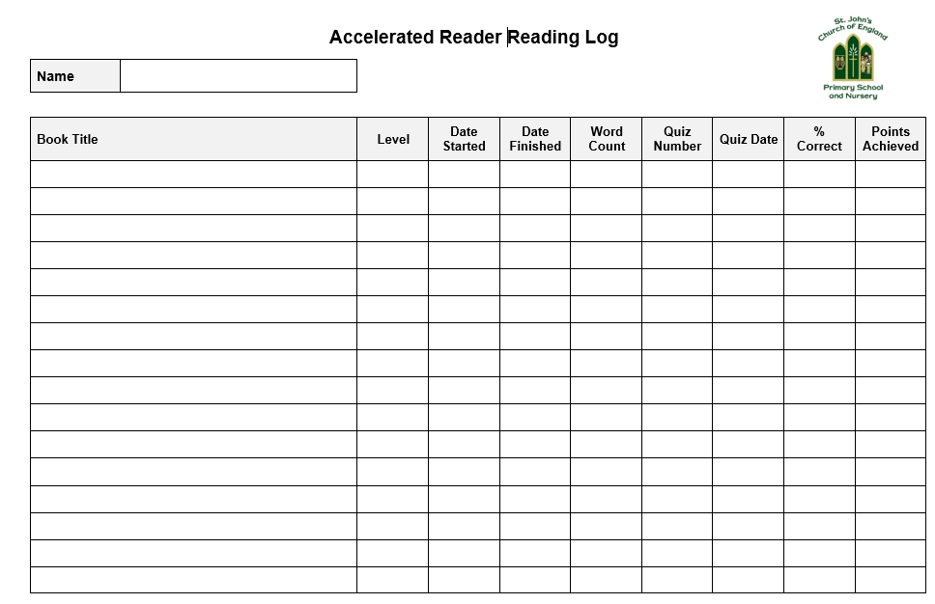

Appendix iii



