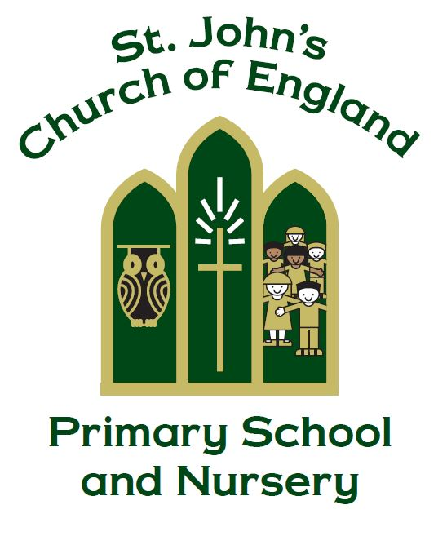

St. John’s C of E (VC) Primary School and Nursery

Assessment, Feedback & Marking Policy

‘If any of you lacks wisdom, let him ask God, who gives generously

to all without reproach, and it will be given him.’

James 1:5

Manager: Mieke Carvell

Policy Produced following consultation with the following parties

Staff on 09.03.15, 08.11.17, 22.01.20 and 06.04.22

Full governors on 16.04.15

Curriculum governors on 24.11.17, 06.02.20 and 19.5.22

Policy review Date: May 2025

This policy is to be used in conjunction with all other policies at St. John’s
C of E Primary School and Nursery

Rationale

At St John’s Church of England Primary School and Nursery we are committed to providing a whole school approach to assessment and effective feedback, achieving maximum impact, which is integral to our children achieving high levels of attainment and progress.

This will ensure that every child understands what their next steps are to improve their learning, therefore closing the gaps and ensuring progress, maximising every child’s potential.

To achieve this vision we aim to use assessment outcomes and effective feedback, both orally and written, to provide a dialogue with each child that will support, consolidate, accelerate and challenge. The feedback we provide from the assessments completed will specifically relate to the learning and will serve to provide greater clarity, address misconceptions, extend learning and, in addition, will be used as a tool to evaluate and assess pupil progress.

Aims

- To use assessment outcomes to inform appropriate feedback and marking to move learning forward building on prior knowledge and skills

- Provide consistency and continuity in feedback and marking throughout the school, so that children have a clear understanding of teacher expectations

- Use the marking system as a tool for feedback and Assessment for Learning

- Create a dialogue which will advance progression and outcomes

- Quantity of feedback should not be confused with quality – time spent on marking should have an impact on pupil progress

- Improve standards by encouraging children to always produce their best and improve on their last piece of work

- Develop children’s self-esteem through praise and valuing their achievements

- To provide opportunities for self and peer assessment

Assessments for primary-aged children

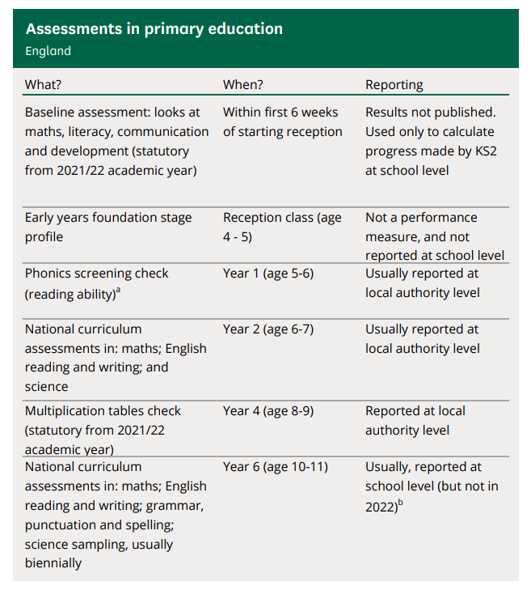

All maintained schools are required to participate in national curriculum assessments; these are referred to as SATs.

Types of assessment

There are two main types of assessment: summative assessment and formative assessment which will be used to inform the feedback and marking provided. These are sometimes referred to as assessment of learning and assessment for learning, respectively. At some level, both happen in almost all classrooms.

Summative assessment sums up what a pupil has achieved at the end of a period of time, relative to the learning aims and the relevant national standards. The period of time may vary, depending on what the teacher wants to find out. There may be an assessment at the end of a topic, at the end of a term or half-term, at the end of a year or, as in the case of the national curriculum tests, at the end of a key stage.

A summative assessment may be a written test, an observation, a conversation or a task. It may be recorded through writing, through photographs or other visual media, or through an audio recording. Whichever medium is used, the assessment will show what has been achieved. It will summarise attainment at a particular point in time and may provide individual and cohort data that will be useful for tracking progress and for informing stakeholders (e.g. parents, governors, etc.).

Formative assessment takes place on a day-to-day basis during teaching and learning, allowing teachers and pupils to assess attainment and progress more frequently. It begins with diagnostic assessment, indicating what is already known and what gaps may exist in skills or knowledge. If a teacher and pupil understand what has been achieved to date, it is easier to plan the next steps. As the learning continues, further formative assessments indicate whether teaching plans need to be amended to reinforce or extend learning.

Formative assessments may be questions, tasks, quizzes or more formal assessments. Often formative assessments may not be recorded at all, except perhaps in the lesson plans drawn up to address the next steps indicated.

It is possible for a summative assessment to be complemented with materials that help teachers to analyse the results to inform teaching and learning (therefore also having formative benefits).

Assessment Points

Teachers are given time at the end of every term to record children’s achievements against age related expectations on iTRACK in Reading, Writing, SPaG and Maths and at the end of every school year in Science, RE and PE.

In the summer term children in years, three, four and five sit a test in reading, SPaG and maths to help inform end of year teacher assessments.

Principles of effective feedback and marking

Effective feedback should focus on moving learning forward, targeting the task, subject, and self-regulation strategies. Before providing feedback, teachers should provide high quality instruction, including the use of formative assessment strategies.

High quality initial instruction will reduce the work that feedback needs to do; formative assessment strategies are required to set learning intentions (which feedback will aim towards) and to assess learning gaps (which feedback will address).

Careful thought should be given to how pupils receive feedback. Pupil motivation, self-confidence, their trust in the teacher, and their capacity to receive information can impact feedback’s effectiveness. Teachers should, therefore, implement strategies that encourage learners to welcome feedback, and should monitor whether pupils are using it.

Teachers should also provide opportunities for pupils to use feedback. Only then will the feedback loop be closed so that pupil learning can progress.

Verbal methods of feedback can improve pupil attainment and may be more time-efficient when compared to some forms of written feedback.

Feedback should focus on moving learning forward, targeting the specific learning gaps that pupils exhibit. Specifically, high quality feedback may focus on the task, subject, and self-regulation strategies.
Pupil books should contain a balance and variety of different marking and feedback strategies.

Effective feedback should:

- be meaningful, manageable and motivating
- be positive and constructive for pupils
- be at a level of understanding for each individual pupil
- be linked directly to the learning
- give clear strategies for improvement/development, positively impacting on progress
- be allocated appropriate time for pupils to respond effectively
- Use the agreed strategies
- Endeavour to provide timely feedback to a child so that the information received is purposeful to the individual's needs.

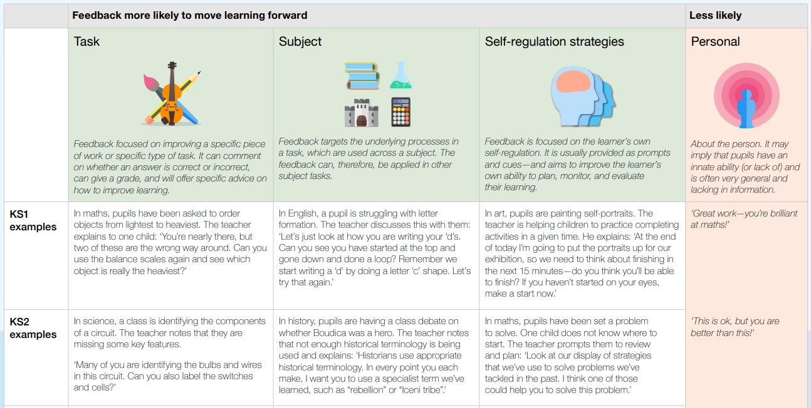
EEF 2022

Implementation

The following strategies will be used as a whole school approach for providing effective feedback, which are closely linked to the learning objective/intention:

Marking Code (Appendix 1) – Marking codes used by all teachers in Key Stage 1 and Key Stage 2, to ensure consistent approach to feedback and marking.

Colour Code (Appendix 2) – Specific colours for feedback and learning outcomes will be used throughout school to provide cohesion for the children

Quality Feedback Dialogue (See Appendix 3) – A focussed comment for improvement to next steps/closing the gaps in learning. This could be reminder prompts to reinforce the learning, scaffold prompts to support and extend learning or example prompts to offer examples and suggestions for improvement.

Success Ladders (Appendix 4) – Success ladders can be used as an assessment tool and to guide future learning. This could be used at the end of a specific piece of work or at the end of a topic.

Verbal feedback - A discussion with the child, which is particularly appropriate and effective for younger, or less able children.

Peer and Self-Assessment – Children will develop a culture of successful and meaningful peer and self-assessment which will be facilitated by the class teacher.

Responding – Feedback completed by the child must receive a response by the class teacher.

Spellings and grammar – mistakes in spelling and grammar, which is age appropriate expectation, should be identified for correction in work using the margin.

Appendix 1

Marking Code

Linked to the Learning Objective and used where appropriate

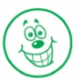  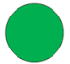     | Objective achieved
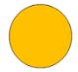  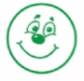 | Progress towards the objective
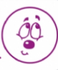  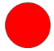   | Objective not achieved yet
 | This answer is correct
 | Correction required
     | Positive feedback  Written in green
   | Next step/Close the gap feedback  Written in red
   | Discussion/Verbal Feedback
SC | Self-checked
PC | Peer-checked
sp | Spelling correction
^ | Missing word
c p | Missing capital letter/punctuation  Red
Arrows used to identify where
Corrections/up-levelling can be made
S | To identify work that has been supported
I | To identify work that has been complete independently
Please note: Stampers or stickers can be used for any of the above
Appendix 2

Colour Code

Feedback Colour Code:

The following colour system will be used in all books.

Green = Positive feedback celebrating success and recognising learning towards the learning objective will be written, by the teacher, in green.

Red = Feedback to move learning forward, targeting the specific learning gaps that pupils exhibit will be written, by the teacher, in red.

KS2:

Colour = Children will use a different colour from the one they used to complete their work, to clearly demonstrate corrections or improvements in work.

Learning Colour Code

A traffic light colour system will be used to identify the outcome of the learning.
Alternatively, stampers or stickers may be used.

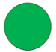
Green – Objective achieved
Amber – Progress towards the objective
Red – Objective not achieved yet

Appendix 3

Quality Feedback Dialogue

Outstanding | - High quality marking leads to high levels of engagement and interest  - Feedback is sharply diagnostic and constructive  - Pupils can identify improvement points in their own work and that of others  - Feedback points are seen as ongoing dialogue  - Pupils understand in detail how to improve their work  - Regular responses to comments from both teacher and pupil
Good | - Marking leads to pupils being clear how well they have done and what they need to do to improve  - Marking shows use of well stated success criteria and, where appropriate, application of basic skills  - Specific improvement points are given  - Opportunities for children to respond to ‘closing the gap’  - Some instances of responses to feedback (by teacher or pupil)  - Self and peer assessment routinely used  - Pupils can identify strengths and improvement points  - Evidence shows that pupils know how to evaluate using criteria  - Targets are accurate and relevant
Requires Improvement | - Marking does not lead to pupils being clear how well they have done and what they need to do to improve  - No specific improvement points are provided - feedback does not demonstrate any impact on advancing pupil progress  - Children are not given the time needed to respond to ‘closing the gap’  - Little or no evidence of responses to feedback (by teacher or pupil)  - Self and peer assessment is predominantly used – no balance of marking/feedback strategies  - Pupils are unable to identify strengths and improvement points

Appendix 4

Success Ladders

Examples of success ladders that can be used, when appropriate (not to be used prior to, or during, composition of an independent piece of writing):
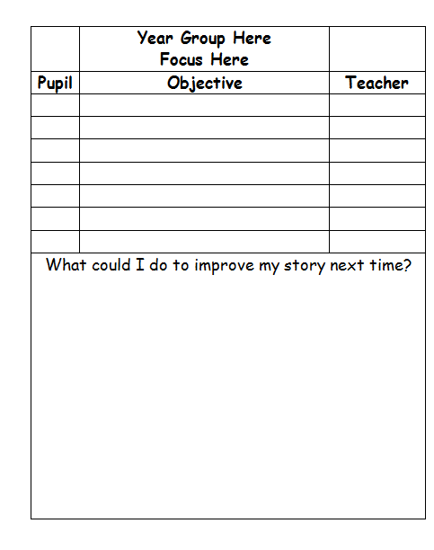
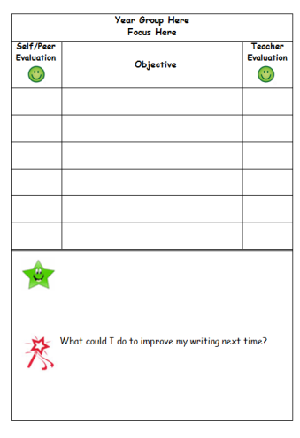
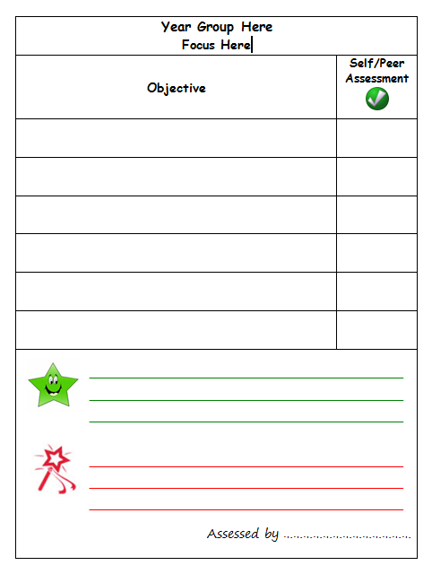

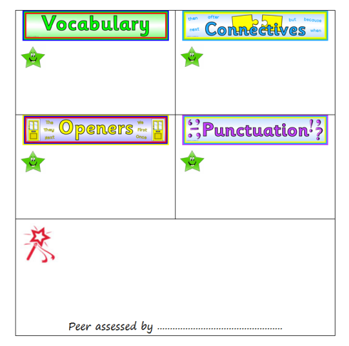
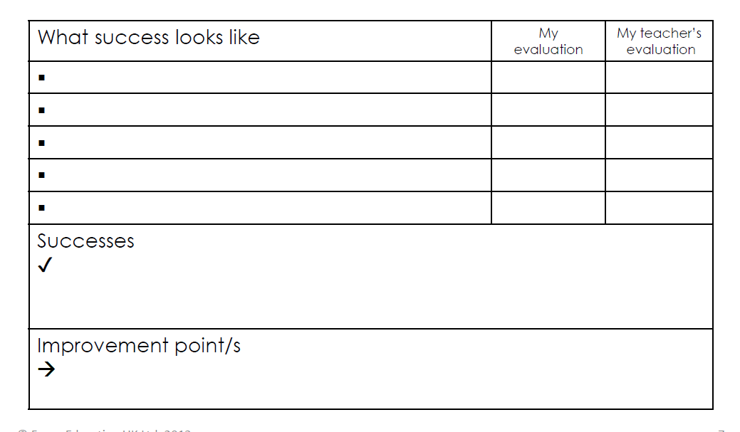

EYFS & KS1 Success Criteria/Ladders:



