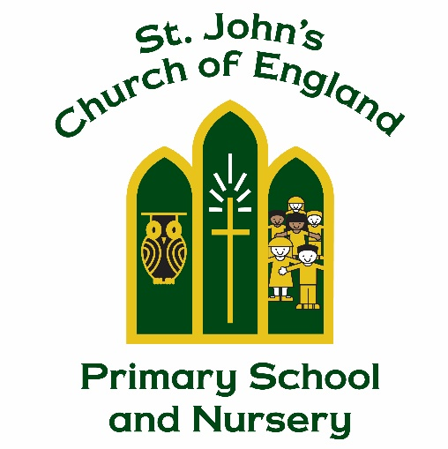

St. John’s Church of England Primary School and Nursery

Food and Nutrition Policy

Manager Mrs Jo Richardson

Policy Produced following consultation with the following parties

“So whether you eat or drink or whatever you do, do it all for the glory of God.”
1 Corinthians 10:31

Full governors on: 8.5.25

Policy review Date: July 2027

Signed by the Chair of Governors

Date ______________________________

This policy is to be used in conjunction with all other policies at St. John’s Church of England Primary School and Nursery

St John’s Church of England Primary School and Nursery
Food and Nutrition Policy

At St John’s Church of England Primary School and Nursery, we believe healthy eating can stabilise children’s energy and promote learning and play.

The statutory framework for the Early Years Foundation Stage 2024 (section 3.51, 3.55, 3.56, 3.57) and the Early Years Foundation Stage nutrition guidance for group and school-based providers and childminders in England April 2025 says that where Early Years settings give children snacks and drinks, these must be healthy, balanced and nutritious.
The Early Years Foundation Stage nutrition guidance April 2025 states that
“Providing healthy, balanced and nutritious food ensures that all children:
• Get the right amount of nutrients and energy they need while they are growing rapidly, which is especially important for children who might not have access to healthy food at home. This can help prevent children from becoming overweight or obese.
• Develop positive eating habits early on. Children’s early experiences with food can shape future eating habits. This can impact children’s long-term health including maintaining a healthy weight, and good oral health.
The early years are a crucial time to reduce health inequalities and set the foundations for a lifetime of good health.”
At St John’s Church of England Primary School and Nursery, we are passionate about using snack and mealtimes to support and educate children in developing healthy lifestyles. Eating represents a social time for children and adults and helps children to learn about healthy eating.

It is important that the children are provided with the four main food groups, these provide essential nutrients to help children grow and develop.

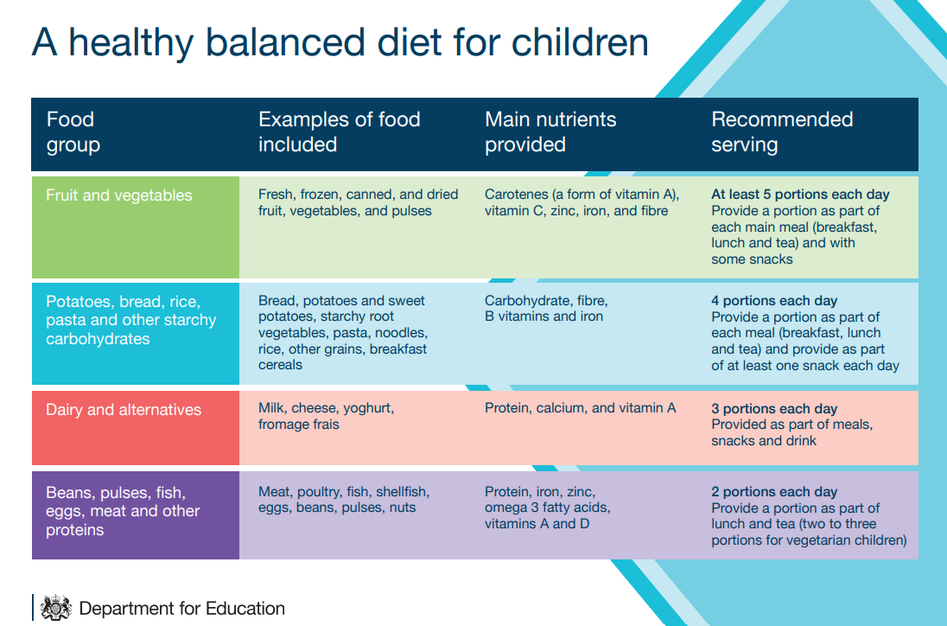

In class food activities linked to the curriculum.

We work alongside parents to ensure any activities and learning tasks based around food meet individual requirements (including specific dietary requirements, and food allergies and intolerances). We ensure that surfaces are wiped and prepared carefully and that the children wash their hands before handling food.
We want children to not only enjoy familiar foods but also expand their confidence in using all their senses to taste, smell, explore and develop new favourites amongst the diverse culinary delights that we aim to offer.
Snack Time
As part of our daily routine the children in nursery and reception are provided with a piece of fruit and milk until their fifth birthday for free, parents can then pay to continue this service with Cool Milk. Children will also have access to their water bottle all day and this is replenished if the child finishes it. The school council voted that on a Monday and Friday children in Reception are allowed to bring a ‘treat snack’ from home. Children are recommended to bring a healthy snack of fruit or vegetables for the rest of the week. School also provides a piece of fruit for each child every day and if snack is left over from the morning children are offered another piece in the afternoon.
During snack time children are instructed to wash their hands before eating and class teachers read a story. This is a calm social time and a good opportunity to talk about the foods that they are eating.
Lunch time in Nursery
Children in Nursery that attend 2 sessions a day (morning and afternoon) are invited to stay in school for their lunch break. During the lunchbreak children will be supervised and supported by St. John’s staff. Children only attending 1 session a day (morning or an afternoon) are not able to stay for lunch. Children need to bring their own pack lunch; however, children that are in receipt of free school meal pupil premium funding are entitled to a free school meal.
The lunch break does not form part of the 30 hours extended entitlement. Parents will need to pay £1.50 per day for their child to stay at school for this 30 minutes. This needs to be paid in advance, before the beginning of each term upon receipt of invoice. Parents that do not pay in time may have their nursery place withdrawn and offered to another family.

Lunchtime in Reception
“The School Food Standards (SFS) regulate the food and drink provided at school settings at both lunchtime and at other times of the school day. The SFS define the foods and drinks that must be provided, which foods are restricted, and those, which must not be provided. They apply to food and drink provided to pupils on school premises up to 6pm, including, for example, breakfast clubs, tuck shops, mid-morning break, vending and after school clubs.” Early Years Foundation Stage nutrition guidance for group and school-based providers and childminders in England April 2025

Children in reception are provided a nutritious lunch time meal in the school hall. The children are taught how to carry their trays, talk to the catering staff with regards to their preferences for their lunch. We encourage and help the children to hold their cutlery correctly and to cut up their food into small mouth sized pieces to prevent choking. We make sure that:
• children eat a balanced diet covering the 4 main food groups
• avoid foods and drinks high in salt, sugar and saturated fat
• milk and water are the only drinks you should offer
• children should eat a variety of fruit and vegetables to access different vitamins and nutrients
Derbyshire catering services are invited to attend the welcome meeting for new reception starters and menus are shared upon request.

Packed Lunches
We encourage parents to provide a healthy and nutritious lunchbox. We encourage parents and/or carers to:
• Ensure the food is suitable for their child’s individual developmental needs and prepared in a way to prevent choking.
• For perishable items that should be kept cool, pack food in insulated sealed bags. If ice packs are unavailable, the ‘4-hour rule’ can be applied. This rule allows food to be stored outside of chilled conditions for up to 4 hours, but this should only be done once during the entire storage.
• Clearly label their child’s name on the lunch bag and detail the contents.
At St John’s we do not have facilities to refrigerate packed lunches for children.

Celebrations
As part of St John’s commitment to promoting healthy eating habits, we ask parents to refrain from providing sweets to celebrate their child's birthday at school. This approach helps us maintain a consistent message about the importance of nutritious choices and supports our efforts to create a healthy environment for all our children.

Universal Infant Free School Meals
All children in reception get a universal infant free school meal. There is no need to apply for these. Children will automatically get one every day, unless parents choose to send them to school with a packed lunch.

Disadvantaged children
Free School Meals Pupils are entitled to free school meals, as long as they either are in full-time education or receive education both before and after lunch and meet the benefits-based free school meal eligibility criteria.

Procedures
We follow these procedures to promote healthy eating in our settings.
- Before a child starts to attend the setting, we ask their parents about their dietary needs and preferences, including any allergies.
- We record information about each child's dietary needs in the Registration Form and parents sign the form to signify that it is correct.
- We regularly consult with parents to ensure that our records of their children's dietary needs – including any allergies - are up-to-date. Parents sign the updated record to signify that it is correct.
- Current information about individual children's dietary needs are kept in the red medical file in the setting so that all our staff and volunteers are fully informed about them.
- We take care not to provide food containing nuts or nut products and we are especially vigilant where we have a child who has a known allergy to nuts.
- Through discussion with parents and research reading, we obtain information about the dietary rules of the religious groups to which children and their parents belong, and of vegetarians and vegans, as well as about food allergies. We take account of this information in the provision of food and drinks.
- We provide a vegetarian alternative on days when meat or fish are offered and make every effort to ensure Halal meat or Kosher food is available for children who require it.
- We use snack and meal times to help children to develop independence through making choices, serving food and drink and feeding themselves.
- We provide children with utensils that are appropriate for their ages and stages of development and that take account of the eating practices in their cultures.
- We have fresh drinking water constantly available for the children. We inform the children about how to obtain the water and that they can ask for water at any time during the day.
- As part of the Government scheme for young children, we provide daily milk for all children.
- Before the children handle or eat any food in the setting we ensure the children have washed their hands and understand the importance of food and hand hygiene.

Legal framework and useful resources:
- Statutory framework for the early years foundation stage: Setting the standards for learning, development and care for children from birth to five
- Early Years Foundation Stage nutrition guidance for group and school-based providers and childminders in England April 2025

- Regulation (EC) 852/2004 of the European Parliament and of the Council on the Hygiene of Foodstuffs.
- Nutrition matters for the early years: Guidance for feeding under-fives in the childcare setting (Ed. 2018)

- Healthy and Active Lifestyles for the Early Years (2012)

