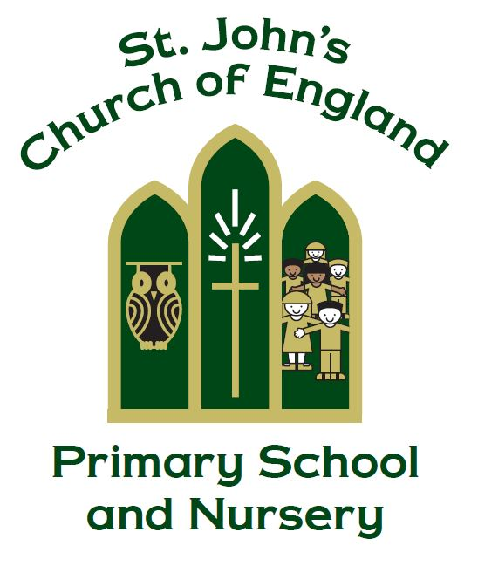

St. John’s CE Primary School and Nursery

Physical Education Policy

An athlete is not crowned unless he competes according to the rules.

2 Timothy 2:5

Managed by Miss H Proud

Policy Produced following consultation with the following parties

Staff on: 01.09.22 and 18.12.25

Curriculum governors on: 13.10.22 and 6.2.25

Policy review Date: October 2027

Signed by the Chair of Governors

Date ______________________________

This policy is to be used in conjunction with all other policies at St. John’s C. of E. Primary School and Nursery and the St. John’s C of E. Primary School and Nursery PE Risk Assessments.

Introduction
As a practical subject, Physical Education offers a unique opportunity to develop our children’s enjoyment, confidence and skills in a safe, challenging and supportive environment. We are hopeful that we can foster co-operation, good sportsmanship qualities and self-esteem through a variety of sports.

A balance of individual and team, co-operative and competitive activities aim to cater for each child’s abilities and preferences. We endeavour to provide our pupils with experiences which will encourage a life-long interest in sport, physical recreation and the knowledge to maintain a healthy, active lifestyle. Opportunities to link physical education work into our cross-curriculum themes will be taken where appropriate with the fundamental aim of encouraging all to participate fully.

Aims
This policy seeks to implement key aims for physical education across the whole school. We aim:
- to develop the ability to plan a range of movement sequences, organise equipment and apparatus and design and apply rules;
- to develop the ability to remember, adapt and apply knowledge, practical skills and concepts and to enable our children to perform a variety of activities;
- to improve observational skills and to foster the ability of our pupils to evaluate their own and others’ performances;
- to encourage a positive attitude to physical activity and healthy lifestyles;
- to develop in our pupils an awareness of their own and others’ skills and thereby to encourage fair play, honest competition and good sporting behaviour,
- to develop responsibility in the storage and maintenance of sports equipment and helping younger/less able pupils,
- to provide all children with a minimum of two hours of PE lessons each week and more physical activity through daily activities when possible

Equal Opportunities/Inclusion
This policy is structured to provide equal opportunities throughout all Key Stages by implementing the following requirements:
- The children are taught in their normal class groups;
- All lessons ensure interest and participation for both boys and girls;
- The link between health and physical exercise is present in each of the areas of activity;
- When partaking in any activity the children are expected to behave in a considerate and responsible manner showing respect to other children and the school equipment.
- Lessons are differentiated to help include children of all abilities and IEPs of SEN children are referred to when necessary.
- TLA support is used in PE lessons if needed.

We will also endeavour to ensure that children who are more able and talented in sports are encouraged, developed and stretched to reach their full potential. This may involve referral to other agencies and external clubs.

Teaching & Learning
The Physical Education programme of study provides the children with the opportunity to learn and develop their skills in a variety of sports and work towards achieving the statements identified for each year group in the ‘Not as We Know It’ grids.

EYFS PE lessons:
- The children are taught to recognise the importance of keeping healthy, safe and exercise
- Recognise that the body changes when they are active
- Move with confidence, imagination, safety, control and coordination
- Safely negotiate space and use a range of small equipment with control

Key Stage 1 & Key Stage 2:
Throughout both key stages the children will participate in a variety of lessons:
- Games
- Athletics
- Gymnastics
- Dance
- Health and fitness

(In KS2 the children will also be taught swimming (in Year 5) and outdoor & adventurous activities through residential trips and orienteering.)

Games & Athletics - There will be a skill based emphasis on the teaching of games with the intention of seeking and encouraging maximum participation. Whenever the weather permits, pupils will be given the opportunities of outdoor activities. The range includes: athletics, football, rugby, hockey, basketball, netball, tennis, tri-golf, rounders, handball, dodgeball and kwik-cricket. Fair play and good sporting behaviour will always be encouraged. The GetSet4PE scheme of work should be followed for games/athletics lessons.

Gymnastics & Dance – Every child will work to create sequences in both gymnastics and dance. They will build their coordination, balance and core strength through structured gymnastics lessons and exploration of movement using apparatus safely. In both gymnastics and dance, we hope to encourage our children to be confident, motivated and engaged, using the GetSet4PE scheme of work.

Swimming - Each child is given the opportunity to learn to swim during Key Stage 2 using the facilities at the Belper Leisure Centre. Children in Year 5 will go swimming throughout the academic year. Sport Premium finances are also used to provide swimming booster sessions for some children in Year 6 who still need to meet the National Curriculum requirements of swimming safely and confidently.

Outdoor and Adventure Activities - Generally pursued in the summer term. Residentials take place in Years 5 and 6 to pursue outdoor and adventurous activities, such as climbing, abseiling and orienteering. Staff may wish to link early orienteering skills with their work during different projects, especially map work. Orienteering equipment is available in school, with a map of the school grounds.

Assessment & Progression
Progression is addressed within each activity area by careful planning of the relevant skills. Children are given the opportunity, as they progress through the Key Stages, to work in a variety of ways using directed, exploratory and improvised activities. The children are encouraged to work as individuals, in pairs and teams and to use language appropriate to the activity when describing their work.

Throughout the school, each class has timetabled PE time to use the hall and playground each week. Management and class teachers should try to ensure pupils’ access at least two hours of PE each week.

The process of assessment is continuous and is used to recognise and record achievements using the following methods:
- Observation
- Pupil self-assessment reviews of their work.
- Teacher assessment is continuous and on-going using the NAWKI grid and year group specific objectives
- End of year PE assessment recorded by teaching staff on iTrack

Careful assessment will enable us to:
- Plan future learning/teaching strategies;
- Identify learning difficulties and provide corrective measures;
- Evaluate each area of the Physical Education programme of study to ensure a strong balance and positive/engaging curriculum.

Teaching Resources (Staff check resources before use. Please report any missing/broken equipment to the PE Lead.)

Gymnastic Apparatus - This is stored around the hall. Children shall be encouraged to set up and put away the apparatus, whenever possible, as part of their lessons. Climbing and large apparatus is checked annually by the County Technical Services Department to ensure its safety and to effect necessary repairs.

Small Equipment - This is stored centrally in the two green sheds situated near the school playground and is kept organised by all staff. This is regularly checked and cleaned by the PE Lead and AVSSP Sports Coaches. Children are not permitted to enter for safety precautions.

Dance Teaching Resources – GetSet4PEscheme of work to be followed for dance lessons and resources can be found online for use in school hall.

Safe Practices
This policy recognises both collective and personal responsibilities taken from the National Standards for safe PE in school and are defined in detail in the schools Indoor and Outdoor PE risk assessments.

Bad weather – Should the weather be too bad for outdoor PE to take place (and the hall is already in use), indoor PE in classrooms will be encouraged. Such as: indoor fitness, dance, boxing fitness, table tennis. (Other lessons available on GetSet4PE)

Getting changed – In Upper Key Stage Two (Years 5 and 6), boys and girls will get changed for PE in separate locations to create a safe environment for all children. Please speak to the specific class teacher for more information.

Footwear – when participating in sports that involve studded boots (such as football or rugby), children will not be able to participate in these activities should other children be wearing studded boots. Groups of children may work separately. Shin pads must also be worn for football when studded boots are being used/worn.
For health and safety reasons, for indoor PE in the school hall, bare feet is required (unless parental permission given for a medical reason). Children are not to wear socks for these lessons due to slippery surfacing and equipment.

PE Kit
- White t-shirt and black shorts
- Spare socks
- Velcro trainers (laces for older children as soon as they are able to fasten)
- Blue/black PE jumper/sweatshirt
- Blue/black leggings/joggers (or blue/black tracksuit to replace above)
- Earrings and jewellery must not to be worn during PE lessons – new earrings to be taped up for 6 weeks and discussed with parents (tape must be applied by the child, not staff)
- Staff not to remove earrings or jewellery
For junior children:
- A house colour t-shirt will also be required (red/green/yellow/blue)
- A pair of football boots may be useful for some sports/activities
Should a child not have their PE kit on the day of their classes PE lesson, home will be contacted first.
Clubs & Competitions
Sports Clubs - Clubs meet regularly for children from Reception upwards where skills, tactics, rules, control and co-ordination are taught. Some of these clubs take place at lunchtimes with specific members of school staff. Please see our school websites PE and Sport Premium page for more information or enquire at the school office.

Inter-House/School - Matches/Competitions are arranged for several sporting activities to promote greater competition and sportsmanship, including Key stage Sports Days, house matches, year group competitions and golden time rewards activities.

