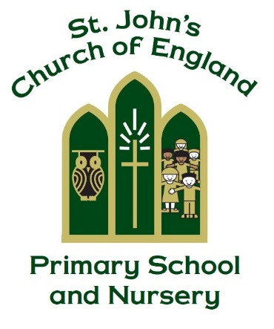

St. John’s CE Primary School and Nursery

“Train up a child in the way he should go, and when he is old, he will not depart from it.” Proverbs 22:6

Religious Education Policy

Manager Miss C Nicklin

Policy Produced following consultation with the following parties

Staff on 1.5.24

Curriculum governors on 23.5.24

Policy review May 2026

Signed by the Chair of Governors

Date ______________________________

This policy is to be used in conjunction with all other policies at St. John’s C. of E. Primary School

Our Vision
Our vision at St John’s is to develop unique, confident, and happy children, within an exceptional Christian learning community, preparing and empowering them for life in a changing world. We strive to enable our children to thrive and succeed, through reaching their academic potential and developing their sense of identity, belonging, purpose and faith. As a school we are committed to providing high-quality sequential religious education through an engaging and challenging curriculum that inspires our children, is accessible to all and is firmly rooted in the teachings of Jesus.

Introduction
RE is central to the purpose of St John’s Primary School because as a church school we see that the Christian faith informs all aspects of our life together. RE in St John’s explores how individuals and communities make meaning and sense of their lives through exploring the major religions of the world as well as non-religious world views. It enables pupils to know about, understand and respond to the important and ultimate questions of life. RE is taught in such a way that it inspires pupils to explore, develop and affirm their own faith and/ or values and have respect for the faith, beliefs and values of others. The Church of England Education Office publish a ‘Statement of Entitlement’ for RE which has been considered in the formation of this policy. At this school, RE supports and strengthens the vision, ethos and values which are at the heart of what we aim to do in every aspect of school life. The importance placed on the development of the whole child spiritually, morally, socially, culturally and intellectually is reflected in the RE curriculum.

Intent
The purpose of RE:
• Religious Education contributes dynamically to children and young people’s education in schools by provoking challenging questions about meaning and purpose in life, beliefs about God, ultimate reality, issues of right and wrong and what it means to be human.
• In RE pupils learn about and from religions and world views in local, national and global contexts, to discover, explore and consider different answers to these questions.
• Pupils learn to weigh up the value of wisdom from different sources, to develop and express their
insights in response, and to agree or disagree respectfully.
• Teaching therefore should equip pupils with systematic knowledge and understanding of a range of religions and worldviews, enabling them to develop their ideas, values and identities.
• It should develop in pupils an aptitude for dialogue, so that they can participate positively in society, with its diverse religions and worldviews.
• Pupils should gain and deploy the skills needed to understand, interpret and evaluate texts, sources of wisdom and authority and other evidence. They should learn to articulate clearly and coherently their personal beliefs, ideas, values and experiences while respecting the right of others to differ.

The principal aim of RE is to engage pupils in systematic enquiry into significant human questions which religion and worldviews address, so that they can develop the understanding and skills needed to appreciate and appraise varied responses to these questions, as well as develop responses of their own.

The curriculum for RE aims to ensure that all pupils:
1. Know about and understand a range of religions and worldviews, so that they can:
• describe, explain and analyse beliefs and practices, recognising the diversity which exists within and between communities and amongst individuals
• identify, investigate and respond to questions posed, and responses, offered by some of the
sources of wisdom found in religions and worldviews
• appreciate and appraise the nature, significance and impact of different ways of life and ways of
expressing meaning.
2. Express ideas and insights about the nature, significance and impact of religions and worldviews, so that they can:
• explain reasonably their ideas about how beliefs, practices and forms of expression influence
individuals and communities
• express with increasing discernment their personal reflections and critical responses to questions
and teachings about identity, diversity, meaning and value, including ethical issues
• appreciate and appraise varied dimensions of religion.
3. Gain and deploy the skills needed to engage seriously with religions and worldviews, so that they
can:
• find out about and investigate key concepts and questions of belonging, meaning, purpose and
truth, responding creatively
• enquire into what enables different individuals and communities to live together respectfully for
the wellbeing of all
• articulate beliefs, values and commitments clearly in order to explain why they may be important in their own and other people’s lives.

Legal Requirements:
The 2002 Education Act states that: Religious education must be taught to all registered pupils in maintained schools, including those in the sixth form, except to those withdrawn by their parents.
The right of parents to withdraw their children from RE is recognised and is stated in the school prospectus.
- In EYFS the recommendation is for 36 hours of RE, integrated into the curriculum. Key Stage 1 children are advised to have 36 hours of tuition and Key Stage 2 children are advised to have 45 hours of tuition over the year. At St John’s RE is taught the equivalent of a lesson a week. It might be that, sometimes, teachers have RE days instead of a weekly lesson.
- Religious ideas may be explored through all subjects including art, dance, drama, literacy, science and maths.
- Whilst recognising that collective worship is entirely distinct from RE, there are often links made between the two which can develop pupils understanding of RE.

Implementation
The organisation of our curriculum enables pupils to build on what they have learned before and allows them to make links across other subjects. RE teaching is planned using the programme of study in the Derbyshire LA Agreed Syllabus for RE 2020-25, which sets out the requirements for RE teaching at each stage of education, including the EYFS. Within the Derbyshire Agreed Syllabus the three fields of enquiry are followed:
- Believing: exploring religious beliefs, teachings, sources; questions about meaning, purpose and truth.
- Expressing: exploring religious and spiritual forms of expression; questions about identity and diversity.
- Living: exploring religious practices and ways of living; questions about values and commitments.

The Understanding Christianity resource was introduced in 2017 and Christianity is mainly taught using the units of work from this. The aims of UC are: To enable pupils to know about and understand Christianity as a living world faith, by exploring core theological concepts.
- To enable pupils to develop knowledge and skills in making sense of biblical texts and understanding their impact in the lives of Christians.
- To develop pupils’ abilities to connect, critically reflect upon, evaluate and apply their learning to their own growing understanding of religion and belief (particularly Christianity), of themselves, the world and human experience.

The approach in RE is to revisit the core concepts throughout the different key stages (a spiral curriculum), deepening pupils’ understanding and making the links to the overall ‘big story’ or ‘salvation narrative’. The Big Frieze illustrates seven of the eight core concepts that are explored in the Understanding Christianity materials. This presents a view of the ‘big story’ of the Bible. It can be used to make pupils aware of the wider context of each concept, unit and text studied in Understanding Christianity. It helps to build up a coherent understanding of the core concepts and the relationship between them.

Breadth of Study: which religions and beliefs and when
The teaching of RE at St John’s reflects and promotes a Christian ethos and Christian values whilst allowing for the freedom of pupils to hold and express different beliefs. In the Agreed Syllabus, schools have considerable flexibility about which religions are taught at each Key Stage, in line with the Law, which states that RE shall have regard for the fact that the religious traditions in Great Britain are in the main Christian, while taking account of the other principal religions represented in Great Britain. In this Agreed Syllabus, this means that pupils must be taught about Christianity in each Key Stage, and schools will select further religions for study in depth in each of KS1-KS2 (See Appendix).

Approaches to Teaching RE
For RE to play its full part within the broad, balanced and coherent curriculum to which all pupils are entitled, we strive to ensure that RE is delivered in ways that make it a lively, active subject by employing a variety of teaching methods; including technology, art, music, discussion, the development of thinking skills, drama, the use of artefacts, pictures, stories and the use of periods of stillness and reflection. Where possible we aim to give pupils opportunities to encounter members of local faith communities through visits to places of worship or visits from members of local faith communities.

Impact:
Teachers are required to assess pupil progress and comment on this as part of the annual report to parents. Teachers assess each unit, using the Learning Outcomes in each unit. Children are assessed as emerging, expected or exceeding. At the end of the year teachers input a level for each child, using itrack. Opportunities for assessment include retrieval quizzes and games, multiple choice questions, self assessments, exit tickets and hinge questions.

Planning and teaching are monitored annually by the RE Coordinator as part of the school monitoring cycle to ensure that there is continuity and that pupils' understanding is deepened as they grow older. Opportunities for monitoring may include lesson observations, work scrutiny, learning walks, analysis of assessment data and pupil voice.

The contribution that RE makes to School Self Evaluation
RE makes a significant contribution to the SIAMS inspection schedule, across many of the seven strands as well as having its own strand as a voluntary controlled school.

The Contribution of RE to Other Curriculum Areas
Spiritual, moral, social and cultural development (SMSC)
SMSC prepares pupils for the opportunities, responsibilities and experiences of later life. Learning about and from religions and beliefs, through the distinct knowledge, understanding and skills contained in RE is essential to achieving these aims. Exploring the concepts of religion and belief and their roles in the spiritual, moral and cultural lives of people in a diverse society helps individuals develop moral awareness and social understanding. Church schools are particularly concerned about the holistic development of children and young people and recognise that a good education is about forming people who have the moral strength and spiritual depth to live a fulfilled life in a society that is marked by rapid change, global competition and insecurity. RE plays a key role in this.

Christian Values
RE along with all the other subjects in the curriculum, should contribute to the promotion of the school’s distinctively Christian values. Making connections between the values and learning in RE will bring about greater understanding of these values, where they come from and how they can be put into practice across a range of experiences.

Global Learning
RE makes an important contribution to a school’s responsibility to promote respect for all, responsible citizenship and global learning. It provides a key context to develop young people’s understanding and appreciation of diversity, to promote shared values and to challenge racism, discrimination & extremism. It can also impact on the school’s duty to promote community cohesion. By examining the beliefs and inspiration provided by key religious figures, RE should also play a part in encouraging pupils to contribute to the school and wider community and to develop attitudes of service to others. RE provides a positive context within which the diversity of cultures, beliefs and values within the school community can be celebrated and explored. It provides opportunities to investigate patterns of diversity of religion and belief in the local community in which it is located and for forging links with different religious groups in the local area in particular local churches. A major focus of RE should be the study of diversity of religion and belief in the UK and how this influences national life. RE also involves the study of matters of global significance recognising the diversity of religion and belief and its impact on world issues.

Promoting British Values
RE provides opportunities to promote and discuss the ‘British Values’ of democracy, the rule of law, individual liberty & mutual respect. These discussions may also play a part in helping schools with their new duties in terms of preventing individuals from being drawn into terrorism. Church of England Schools can be seen as part of the solution to the threat of radicalism. This should involve not just trying to prevent the development of an extremist view but should be more about promoting a positive vision of the contribution of different religions. This means high quality religious education should equip children with accurate information and critical skills.

Appendix
EYFS & KS1

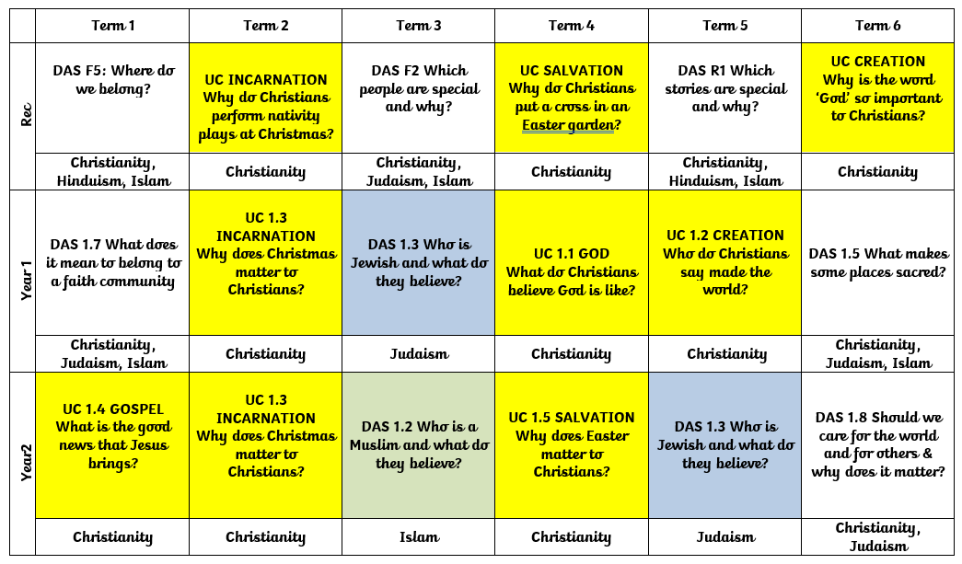

KS2



