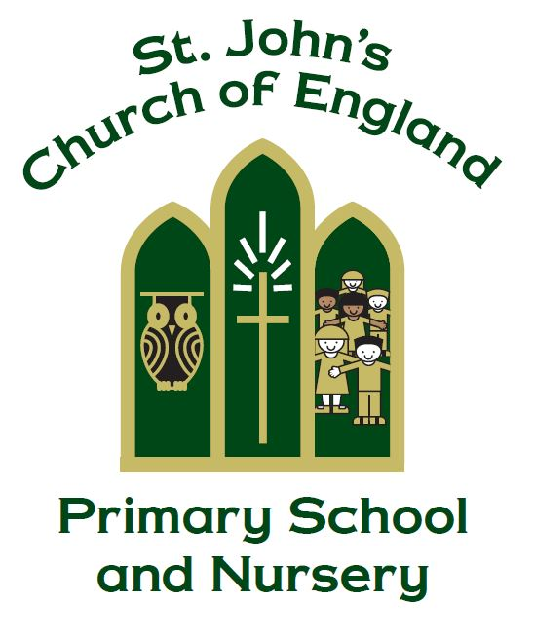

St. John’s CE Primary School and Nursery

PSHE and Relationship & Sex education Policy

From Him the whole body, joined and held together by every supporting ligament, grows and builds itself up in love, as each part does its work

Ephesians 4:16

Manager: Mrs D Girling

Policy Produced following consultation with the following parties

Full governors on 8.5.17 - 9.5.19 - 7.7.22 – 10.7.25

Curriculum governors on 23.5.19 – 23.5.24 – 22.5.25

Policy review Date May 2026

Signed by the Chair of Governors

Date ______________________________

This policy is to be used in conjunction with all other policies at St. John’s C. of E. Primary School

We have based our school’s sex education policy on the DfE’s consultation (July 2018) Relationships Education, Relationships and Sex Education (RSE) and Health Education. In this document, sex education is defined as:

‘Learning about physical, moral and emotional development.’ It is about understanding the importance of marriage for family life, stable and loving relationships, respect, love and care. It is also about the teaching of sex, sexuality, and sexual health’.

We have also considered the DfE policy statement, relationships education, relationships and sex education and personal, social health and economic education, published on 1.3.17.

Sex education is part of the personal, social and health education curriculum in our school. While we use sex education to inform children about sexual issues, we do this with regard to matters of morality and individual responsibility, and in a way that allows children to ask and explore moral questions.

Rationale

We want the subjects to put in place the key building blocks of healthy, respectful relationships, focusing on family and friendships, both on and offline. We define RSE (within PSHE) as being part of lifelong learning about the emotional, social and physical aspects of growing up, relationships, sex, human sexuality and sexual health. It aims to give pupils essential skills for building positive, enjoyable, respectful and non-exploitive relationships and to stay safe on and offline. It enables exploration of attitudes and values, helps build self-esteem and confidence to view their sexuality positively.

Relationship and Sex Education is not just learning about growing up, changes and reproduction. It is also about enabling children to make and maintain relationships with others, to understand about human sexuality and to feel good about themselves and the choices they make. This involves helping children to gain knowledge, develop skills and form positive beliefs and attitudes. This will sit alongside the essential understanding of how to be healthy. Teaching on mental wellbeing is central to these subjects, especially as a priority for parents is their children’s happiness. All of this content should support the wider work in helping to foster pupil wellbeing and develop resilience and virtues that we know are fundamental to our pupils being happy, successful and productive members of society. This should be complemented by development of virtues like kindness, generosity, self sacrifice and honesty.

Delivery of the basic and national curriculum Year 1-6.

The teaching of PSHE in Early Years Foundation Stage is covered through the Early learning Goals and supplemented by the EYFS units in PSHE Matters.

Years 1-6 will use PSHE Matters: A PSHE Curriculum for Primary Schools to deliver PSHE lessons. 12 units of PSHE related modules will be delivered across Years 1 and 2, Years 3 and 4 and Years 5 and 6. Each year, children will complete 6 of the 12 modules. The modules are Drug Education, Exploring Emotions, Being Healthy, Growing Up, Changes, Bullying Matters, Being Me, Difference and Diversity, Being Responsible, Being Safe, Relationships and Money Matters.

Class teachers will choose an appropriate amount of time to allow them to deliver the half termly unit successfully. It may be that the unit is taught in a weekly lesson, varying in length from 10 to 60 minutes throughout the half term, or that the class has a PSHE afternoon or day. On average, PSHE will be taught for 30 minutes per week.

Delivery of Relationship and sex education – RSE education

All children will be taught RSE through the ‘Relationships’ (in Years 1, 3 and 5) and ‘Growing Up’ (in Years 2, 4 and 6) modules. The modules begin in KS1 thinking about the process of growing from young to old, naming some body parts related to human reproduction and building healthy relationships. Lower KS2 will be thinking further about what constitutes a healthy relationship, learning the names of body parts related to human reproduction and how a baby develops in the womb. Upper KS2 will be taught about puberty, human reproduction and again, developing healthy relationships. The national curriculum for science also includes subject content in related areas, such as the main external body parts, the human body as it grows from birth to old age (including puberty) and reproduction in some plants and animals.

The children will be taught via a range of strategies including discussion, games, videos and books.

There will be a question box available for children to put any questions they have, anonymously. The teacher can select appropriate questions and answer them in an informative and sensitive manner.

Safe and effective practice

Teachers set a group agreement or ground rules with pupils to ensure that a safe and supportive atmosphere is created where pupils feel able to ask questions, discuss concerns, talk about feelings and relationships. These rules and expectations will be set out at the beginning of each lesson. Pupils will also be able to raise questions anonymously by the use of a PSHE question box in the classroom. Staff will devise an agreed protocol which they will follow to deal with potentially sensitive issues or use to seek support. Questions will be answered honestly and sensitively, appropriate to the age and maturity of the pupils. Some questions may be more appropriately answered on a one-to-one basis, rather than with the whole class. Teachers will refer to the Vocabulary Mapping document to ensure that vocabulary related to private body parts, puberty and reproduction are introduced at an age-appropriate time (see appendix).

The RSE policy reflects and is line with our equal opportunities policy and the school ensures that the RSE teaching programme is an inclusive one and is appropriate and relevant to all pupils, including those with SEN and disabilities. Teachers ensure that the content, approach and use of inclusive language reflect the diversity of the school community, and help all pupils feel valued and included, regardless of their gender, ability, disability, experiences and family background. Where needed, RSE is differentiated to meet the needs of pupils and specialist resources may be used to respond to their individual needs. In some cases pupils have individual support or work in small groups with a TA.

Teachers do not discuss details of their personal relationships with pupils.

Teachers are sensitive to the issues of different types of relationships. Promoting inclusion and reducing discrimination are part of RSE throughout the school and reflect our equality policy. When teaching about relationships and families we also include same sex relationships. The teaching programme in Year 5 and 6 will include specific understanding of different types of relationships.

Homophobic and transphobic references and homophobic and transphobic actions and bullying are not tolerated in school and are challenged and dealt with as part of our commitment to promoting inclusion, gender equality and preventing bullying. Developing the correct terminology will be a key part of teaching to make it clear that everybody uses common words and so avoid using prejudiced or offensive language.

Teaching about different families is part of RSE and we aim to reflect the broad range of experiences amongst pupils and ensure all pupils feel their family is valued, such as: single parent families; recently divorced parents; parents who are married, parents who are not married, parents who have non-monogamous relationships; lesbian, gay or bisexual parents; children living between two homes; in foster homes; in residential homes and living with relations other than biological parents. We will emphasise the importance of strong and supportive relationships, including marriage (both heterosexual and gay) and civil partnerships, for family life and bringing up children.

RSE lays the foundations for developing empathy and understanding between girls and boys, young men and young women. Pupils should be encouraged to consider the importance of equality and respect within friendships and relationships, and to develop positive, non-violent behaviour. They should learn to recognise physical, sexual and emotional violence and how to get help if they need it. RSE must provide a clear message that violence and exploitation are always wrong, that everyone is responsible for their own behaviour and that no one is ever responsible for the violence or abuse they experience

Parental Consultation for relationship and sex education

We place the utmost importance on sharing responsibility with parents and carers for their children’s education. We will take every opportunity to inform and involve parents and carers by:

● Making the policy available on the school’s website

● Discussing individual concerns and helping parents and carers support the needs of their children.

- The RSE lead will run an annual parent workshop when parents will be invited into school to come and observe the resources and curriculum for the year group that their child is in to help inform them of what their child will be taught that year.

Parents have the right to request that their child be withdrawn from some or all of sex education delivered as part of statutory RS, but not Relationships Education. If a parent wishes to withdraw their child from the RSE curriculum they must arrange a meeting with the Head teacher who will talk through their concerns and discuss the benefits of school RSE. If they decide to withdraw their children, we will offer advice on the teaching and materials available if parents wish to use this with their children at home. Parents can talk to the PSHE Coordinator about the resources to support this. Even when a child has been withdrawn from RSE lessons, if the child should ask questions at other times, these questions would be answered honestly by staff.

RSE support for parents

The following resources are recommended for parents to support their children, at home, regarding any aspect of Relationships and Sex Education, including puberty.

Information about female puberty PP RSE Parents.pdf

Puberty for girls | Childline

Periods | Childline

Whats Happening to Me? | Usborne | Be Curious for children 9+

Growing up for Girls | Usborne | Be Curious for children 10+

Information about male puberty PubertyLeaflet_Boys.pdf (wchc.nhs.uk)

Puberty for boys | Childline

Growing Up for Boys | Usborne | Be Curious for children 10+

Whats Happening to Me? (Boy) | Usborne | Be Curious for children 9+

Male and female puberty 4youmarch2010nonprinting.pdf (www.nhs.uk)

Lift-the-flap Questions and Answers about Growing Up | Usborne | Be Curious for children 7+

Appendix

St. Johns CE Primary & Nursery School
Mapping vocabulary for private body parts, puberty and reproduction

 | EYFS 1 & 2 | Y1/Y2 | Y3/Y4 | Y5/Y6
penis
vagina
pregnant
breasts
nipples
testicles
adoption
fostering
Same sex family
genitals
anus
sperm
egg
umbilical cord
ovaries
ovary
ovum
pubic hair
period
hormones
attraction
fancy
crush
sexual intercourse
conception
semen
erection
ovulation
fallopian tube
labia
womb
vulva
clitoris
cervix
foreskin
wet dream
masturbation
ejaculation
foetus
embryo
gay
lesbian
transgender
inter-sex
menstruation
discharge
caesarean

