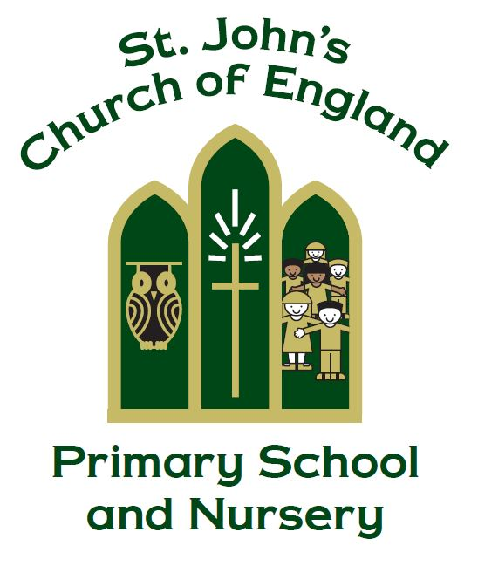

St. John’s CE Primary School and Nursery
I applied my mind to examine and explore through wisdom all that is done under heaven
Ecclesiastes 1:13

Science Policy

Manager Miss J. Martin

Policy Produced following consultation with the following parties

Staff on 9.3.16, 15.05.19, 8.3.23, 21.05.25

Full governors on 10.3.16, 10.7.25

Curriculum governors on 23.5.19, 18.05.23 & 22.05.25

Policy review Date: May 2027

Signed by the Chair of Governors

Date ______________________________

This policy is to be used in conjunction with all other policies at St. John’s C. of E. Primary School

- Rationale

Science is a body or knowledge built up through experimental testing of ideas. Science is also a methodology, a practical way of finding reliable answers to questions we may ask about the world around us. A good understanding of scientific knowledge and conceptual understanding helps to support pupils work across the curriculum. Science at St John’s is about developing children’s ideas and ways of working that enable them to make sense of the world in which they live, through investigation, as well as using and applying process skills. Our Christian foundations are mutually supportive of our science curriculum and our science lessons help children grow and learn in a fun environment.

We believe that all pupils must have regular access to science appropriate to their age and stage of development, and that emphasis should be given to this as a core subject.
At St John’s we aim to:
- Prepare our children for life in an increasingly scientific and technological world
- Foster concern about, and active care for our environment
- Help our children acquire a growing understanding of scientific ideas
- Help develop and extend our children’s scientific understanding of the world
We seek to promote these by:
- Encouraging the development of positive attitudes in science
- Building on our children’s natural curiosity and developing a scientific approach to problems
- Providing our children with an enjoyable experience of science, so that they will develop a deep and lasting interest
- Encouraging open-mindedness, self-assessment, perseverance and responsibility
- Building our children’s self-confidence to enable them to work independently
- Develop our children’s social skills to work co-operatively with others
And acquiring the skills:
- Giving the children an understanding of scientific processes
- Helping our children to acquire practical scientific skills
- Developing the skills of investigation
- Developing the use of scientific language, recording and techniques
- Developing the use of ICT in investigating and recording
- Enabling our children to become effective communicators of scientific ideas, facts and data

- Teaching
We teach science (National Curriculum 2014 and Early Years Foundation Stage curriculum (EYFS)) in ways that are imaginative, purposeful, well-managed and enjoyable. We enable our children to make links between science and other subjects through the Cornerstones curriculum.

Children in our EYFS classes are taught the science aspects of the EYFS curriculum through the Knowledge and Understanding of the World area of study.

Children in our EYFS classes enjoy a very practical and hands-on approach to science. Teachers and teaching assistants support pupils to develop a solid understanding of things occurring around them in their everyday lives. Children are encouraged to be creative and inquisitive as they participate in activities. Children are encouraged to use their natural inquisitiveness while taking part in exploratory play.

Science in the National Curriculum has 3 disciplines, Biology: plants, animals including humans, living things and habitats, evolution and inheritance; Chemistry: rocks, everyday materials, properties and changes of materials, states of matter; physics: light, sound, forces and magnets, seasonal changes, earth and space, and electricity. Working scientifically is taught through each programme of study, teaching children to ask questions, use scientific evidence, observe, test, identify and classify, use results, record, and report and present their findings.

Children in Key stage 1 observe, explore and ask questions about living things, materials and the world around them. They begin to work together to collect evidence to help them to answer questions, find patterns, classify and group objects, research using a variety of sources and carry out simple tests. They share their ideas and communicate them using scientific language, drawings, charts and tables.

Children in Key stage 2 are encouraged to extend the scientific questions they ask and answer about the world around them. They carry out a range of scientific enquiries including: observations over time, pattern seeking, classifying, grouping and researching using other sources (including computer resources).

We record our findings using our science template which clearly identifies the steps of the investigation process.

- Planning, continuity and progression
At the start of the school year, year groups begin to plan based on the Curriculum 22 Knowledge Rich Projects (KRPs) they will be teaching that year. A Science whole school overview of progression is then created with a sequential approach and the knowledge and skills being covered across the school is checked to ensure full PoS coverage. Lesson plans are then readily available to access on Cornerstones Maestro. Teachers adapt and modify the plans to suit their children’s needs and interest, current events, their own teaching style, the availability of any support staff, resources available and opportunities available in the local area.

- Our approach to science
The essential elements describing how Science is taught at St John’s are described below:
- We have adopted the Cornerstones Curriculum 22, which is a project-based curriculum providing opportunities for children to explore, learn and respond in a variety of ways, and allowing children to follow their interests and needs.
- When teaching a Knowledge Rich Project (KRP), all Science LOs must be taught to ensure full PoS coverage.
- We use homework to support school and class activities where appropriate, usually through the KRP.
- We use cross-curricular links to Science wherever possible, developing skills in other subjects through Science.
- Science displays are found in every classroom when a KRP has a specific Science focus and are used to emphasise the importance of Science. Wherever possible interactive displays will be planned for pupils to explore.

- Equal opportunities in Science
Science is taught through the guidelines of the school’s equal opportunities policy. We ensure that all our children have the opportunity to gain scientific knowledge and understanding regardless of gender, race, class, physical or intellectual ability. Our expectations do not limit pupil achievement, and assessment does not involve cultural, social, linguistic or gender bias. We aim to teach Science in a broad global and historical context, using the widest possible perspective and including the contributions of people of many different backgrounds. We value science as a vehicle for the development of language skills, and we encourage children to talk constructively.

- Assessment and recording in Science
We use a varied system of Science assessment including self and peer assessment, feedback and reflection. We use assessment to inform and develop our teaching. We mark each piece of work constructively and positively, making it clear orally or on work, where the lesson objective has been met, how work could be improved, and understanding deepened, where appropriate. The children in our EYFS classes are assessed using the Development Matters Age Phase objectives, this is started on entry to school and completed by the end of their journey through the EYFS phase. In KS1 and KS2, we record progress against objectives using ‘Not As We Know It’ grids and input results into ‘iTrack’ in the Summer term, where progress can be monitored and analysed. Staff are welcome to input Science data in Autumn and Spring term (if a Science topic has been fully taught). Reports to parents are made three times a year through parents’ consultation, and in the summer parents receive a written report.

Conclusion
This policy should be read in conjunction with the following policies:
- Teaching and Learning Policy
- Feedback, Marking and Assessment Policy
- Equal Opportunities Policy

Investigation template KS1
LO: ________________________________________________________________

Question: __________________________________________________

Enquiry type (tick): simple test observation over time identifying and classifying
pattern seeking research

Equipment/ materials:
- ______________________________
- ______________________________
- ______________________________
- ______________________________

Prediction:
________________________________________________________________

Method/ Procedure:
- ______________________________
- ______________________________
- ______________________________

Results/ table:

Conclusion:
We found out that_____________________________________________________________
___________________________________________________________________________
___________________________________________________________________________
I think this is because___________________________________________________________
___________________________________________________________________________
___________________________________________________________________________

Questions raised:
____________________________________________________________________________________________________________________________________________________________

Investigation Template KS2
LO: ________________________________________________________________

Question: __________________________________________________

Enquiry type (tick): fair test observation over time identifying and classifying
pattern seeking research

Equipment/ materials:
- ______________________________
- ______________________________
- ______________________________
- ______________________________

Prediction:
________________________________________________________________

Method/ Procedure:
- ______________________________
- ______________________________
- ______________________________

Results/ table:

Conclusion:
We found out that_____________________________________________________________
___________________________________________________________________________
___________________________________________________________________________
I think this is because___________________________________________________________
___________________________________________________________________________
___________________________________________________________________________

Questions raised:

____________________________________________________________________________________________________________________________________________________________

