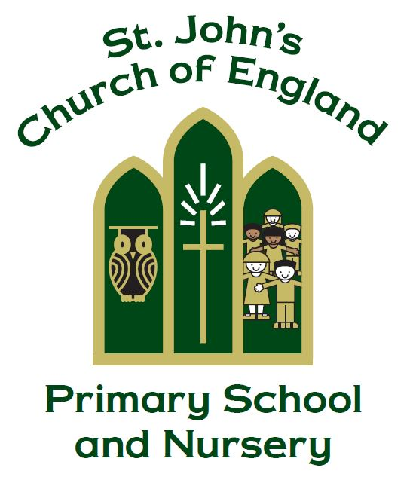

St. John’s CE Primary School and Nursery

Matthew Chapter 7 Verse 12
“So in everything, do to others what you would have them do to you”

SMSC Policy

Manager Cairen Nicklin

Policy Produced following consultation with the following parties

Staff on 13.2.19

full governors on 4.7.24

Policy review Date June 2026

Signed by the Chair of Governors

Date ______________________________

This policy is to be used in conjunction with all other policies at St. John’s C. of E. Primary School and Nursery

Provision for the spiritual, moral, social and cultural development of pupils includes developing their:
- ability to be reflective about their own beliefs, personal qualities and perspective of life.
- knowledge of, and respect for, different people’s faiths, feelings and values
- sense of enjoyment and fascination in learning about themselves, others and the world around them.
- use of imagination and creativity in their learning.
At St. John’s CE Primary School and Nursery, we seek to teach these qualities across the curriculum and throughout school life. It is linked closely to our school vision and ethos.

Vision
- We aim to promote the development of develop unique, confident and happy children within an exceptional Christian learning community preparing and empowering them for life in a changing world.

Ethos
- St John’s is a family – we care for each other; encourage each other; celebrate and have fun together, and help each other along.
- St John’s is a safe place – where children are valued, and taught to appreciate diversity and value each other - to show respect for people, and for the world.
- St John’s is a hard working place – children are encouraged to aim high; to achieve the best they can; through innovative, inspirational, and high quality teaching.
- St John’s is a welcoming place – we live, work, and pray in partnership with our families; our local church; and the wider community.

Our aims in teaching SMSC are:
SPIRITUAL EDUCATION

- To develop the pupils’ understanding of the Christian Faith
- To be aware of our own spiritual journey through individual experiences.
- To develop self-knowledge or self-awareness leading to an appreciation of Christian identity.
- To sustain self-esteem, self-confidence, self-respect and self-worth.
- To celebrate and share strengths.
- To share difficulties, admit problems, and ask for help.
- To promote enjoyment of life and learning.
- To form positive relationships and accept the individual worth of each other.
- To ask questions – the search for the ultimate meaning and purpose of life.
- To facilitate a sense of awe and wonder, by encouraging a response to the beauty and uniqueness of our world and the context of God who gave us these gifts.
- To appreciate the intangible – beauty, truth, love, goodness.
- To contemplate, discuss and attempt to come to terms with issues such as death, war, famine.
- To promote opportunities for reflection – savour ‘the special moment’.
- To foster the emotional life of children, particularly with regard to the experience of feelings.
- To help children express their innermost thoughts and feelings through the creative arts.
- To help children search for their own beliefs and values.

MORAL EDUCATION

- Establish classroom/playground/school rules and sanctions which children help to evolve.
- Set clear guidance for what is right and wrong and offer opportunities to discuss these issues, in the light of Christian teaching.
- Give appropriate praise.
- Celebrate achievement, success and effort.
- Opportunities for children to make choices and decisions on ethical issues and personal values.
- Opportunities to participate in co-operative group work.
- Help children become increasingly aware of the consequences of their actions on others and on the environment.
- Develop respect and courtesy for others and expect others to treat you with respect and courtesy.
- Be fair and expect fairness.
- Understand the need to review and re-assess values, codes and principles in the light of new experience.
- Impart information, share concerns and discuss moral issues with parents.
- Encourage children to seek adult support if they have concerns.

SOCIAL EDUCATION

- Understand their place in and the contributions children can make, to their home, school and the wider world.
- To be able to work and play well with others.
- Develop increasing ability to share, take turns, respect others, and show kindness towards others.
- Develop positive relationships.
- Develop strategies to cope with behavioural difficulties of other children.
- Learn to support and give equal regard to the least popular children and those with disabilities.
- Develop independence and responsibility.

CULTURAL EDUCATION

- Develop increasing understanding of the influence of Christianity on our culture.
- Develop increasing understanding of others cultures both in our own country and throughout the world – that cultures are dynamic and evolutionary – and to celebrate the heights of human achievement in all cultures and societies.
- Develop increasing tolerance and acceptance of all cultures.
- Accept that there is no right or wrong in terms of cultural heritage.
- Develop understanding of cultural similarities and differences – and learn to celebrate both.
- Understand importance of significant language, buildings, icons and images in different cultures as well as in the Christian culture.

SMSC in Collective Worship
Collective Worship is the beating heart of St John’s Primary School. It provides opportunities for our school community to share experiences, ideas and understanding. It provides the opportunity for pupils to become aware of the importance of reflection and how our positive and negative experiences can be formative. Through Collective Worship, pupils are offered a space and a place for hearing the Christian story. Opportunities are given to reflect the positives life such as joy and beauty of the world, as well as time to reflect on moments of disappointment or pain. Time is given for celebration, both of accomplishments and to mark seasonal Christian festivals. Collective Worship is invitational, inspirational and inclusive.

SMSC is taught throughout the curriculum. The examples below are not exhaustive but are intended to give an idea as to when children’s understanding of SMSC is developed.

The Contribution of Religious Education
RE makes a distinctive and substantial contribution to the delivery of SMSC:
- Pupils learn about beliefs, values and the concept of spirituality.
- RE reflects on the significance of religious teaching in their own lives.
- Develops respect for the right of others to hold beliefs different from their own.
- Shows an understanding of the influence of religion on society.
- Fosters appreciation and understanding of different cultures, religions and traditions.
- Visits to places of worship from other religions.

The Contribution of English
- Developing confidence and expertise in language, which is an important aspect of individual and social identity.
- Enabling pupils to understand and engage with the feelings and values embodied in high quality poetry, fiction, drama, film and television.
- Developing pupils’ awareness of moral and social issues in fiction, journalism, magazines, radio, television and film.
- Helping pupils to understand how language changes over time, the influences on spoken and written language and social attitudes to the use of language.

The Contribution of Mathematics
- Spiritual development: through helping pupils obtain an insight into the infinite, and through explaining the underlying mathematical principles behind natural forms and patterns.
- Moral development: helping pupils recognise how logical reasoning can be used to consider the consequences of particular decisions and choices and helping them learn the value of mathematical truth.
- Social development: through helping pupils work together productively on complex mathematical tasks and helping them see that the result is often better than any of them could achieve separately.
- Cultural development: through helping pupils appreciate that mathematical thought contributes to the development of our culture and is becoming increasingly central to our highly technological future, and through recognising that mathematicians from many cultures have contributed to the development of modern day mathematics.

The Contribution of Science
- Encouraging pupils to reflect on the wonder of the natural world.
- Awareness of the ways that Science and Technology can affect society and the environment.
- Consideration of the moral dilemmas that can result in scientific developments.
- Showing respect for differing opinions, on creation for example.
- Co-operation in practical activity.
- Raising awareness that scientific developments are the product of many.

The Contribution of Computing
- Preparing the pupils for the challenges of living and learning in a technologically enriched, increasingly interconnected world.
- Making clear the guidelines about the ethical use of the internet.
- Acknowledging advances in technology and appreciation for human achievement.

The Contribution of History
- Looking at the creation and evolution of British society.
- Enabling pupils to reflect on issues such as slavery, the holocaust, racism, etc.
- Showing an awareness of the moral implications of the actions of historical figures.

The Contribution of Geography
- Opportunities for reflection on the creation of earth and its’ origins, future and diversity.
- Reflection on the fair distribution of the earth’s resources and issues surrounding climate change.
- A study of people and physical geography gives our pupils the chance to reflect on the social and cultural characteristics of society.

The Contribution of Modern Foreign Languages
- Gaining insights into the way of life, cultural traditions, moral and social developments of other people.
- Social skills are developed through group activities and communication exercises.
- Listening skills are improved through oral work.
- Fables and folk tales are dramatized, which prompt discussion of values and mindsets.

The Contribution of Art
- Art lessons develop pupils' aesthetic appreciation.
- In turn, Art evokes feelings of 'awe' and 'wonder'.
- Giving pupils the chance to reflect on nature, their environment and surroundings.
- Studying artists with a spiritual or religious theme, issues raised by artists which concerns ethical issues, such as War paintings or global issues.

The Contribution of Design Technology/Food Technology
- Reflecting on products and inventions, the diversity of materials and ways in which design can improve the quality of our lives.
- Awareness of the moral dilemmas created by technological advances.
- How different cultures have contributed to technology.
- Opportunities to work as a team, recognising others strengths, sharing equipment.
- Giving the opportunity to examine cultural differences in food and diet.
- Reflecting on the social issues around food such as price and income.
- Acknowledging government guidelines for health and dietary requirements.
- Reflecting on the moral issues concerning food production in third world countries.

The Contribution of Music
- Teaching that encourages pupils to be open to the music of other cultures.
- Discussing and reflecting upon a range of personal experiences (own performance) and observed experiences (trips, concerts and peer performances).
- Lead pupils to appreciate aesthetic order, beauty and on occasion ambiguity, for example through listening activities, where possible beyond their common experience.
- Looking at the way music can change moods and behaviour.
- Offer a range of high quality on-timetable and off-timetable music enrichment activities, for example access to individual instrumental/vocal/theory lessons with specialist peripatetic teachers, opportunities to play/sing in concerts, etc.

The Contribution of Physical Education
- Activities involving co-operation, teamwork, competition, rules, self-discipline and fair play.
- Individual activities that provide the opportunity for self-reflection, awareness and challenge.

Beyond the Curriculum
Opportunities for SMSC growth happen throughout each and every day at St John’s as children engage in learning, play and reflection, allowing children to deal with delight, disappointment and the chance to reflect. We deliver SMSC through a variety of ways beyond the curriculum:
- St. Peter’s vicar regularly support school, for example, monthly prayer meetings, leading collective worship, church workshops.
- School Council – each class is represented.
- Through our links with Scott Lane School in Kolkata India.
- Links with Amber Valley Schools Sports Partnership
- Through community events, for example our annual Summer Fair and Family Chip and Quiz night
- Our extensive Extra-Curricular Programme, that includes sports and creative activities.

MONITORING AND IMPLEMENTATION OF THE POLICY
- Provision for SMSC is monitored and reviewed by the SLT, teachers, pupils and members of the Governing body.
- Regular discussions are held at staff meetings.
- Staff share classroom work and practice.
- The implementation of this policy is the responsibility of all staff.

